BROWNIE PAN RECIPE BOOKLET

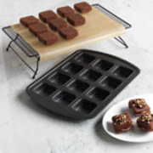

Judy Emmons
Independent Consultant & Trainer for The Pampered Chef
231-878-7724
jlynn133@hotmail.com

Table of Contents

BREADS
Cinnamon Crunch Cobblestone Muffins
Mini Banana Bread Loaves
Cinnamon Sugar Loaves
Feta Cheddar and Spinach Muffins
Green Chili Cheddar Loaves
Mexi-Cornbread
Michele's Mini Irish Soda Breads
Southwest Cornbread
Busy Mom Puffins (Pancake Muffins)
Mini Monkey Bread

BREAKFAST

Breakfast Bakes
Brunch Squares
Pumpkin Pancake Muffins (GLUTEN FREE)
Double Berry Muffin Squares
German Pancake
Mini Cheddar Bacon Brunch Loaves
Mini Omelets
Egg Tarts in the Brownie Pan

BROWNIES & CAKES

Almond Pound Cake
Brownies – GLUTEN FREE
Brownies – Healthier (Weight Watchers ~4 points)
Brownies – Ice Cream Sandwiches
Cinnamon Pecan Blondie Bars
Brownies – Peanut Butter & Jelly Sandwiches
Brownies – Reese's Cup Cookie
Brownies – Triple Layer
Brownies – Turtle Fudge
Chocolate Chip Cookie Sensation
German Chocolate Whoopie Pies
Easter-Time Rice Krispie Treats
Key Lime Cupcakes
Cupcakes
Lemon Raspberry Mini Cakes
Phyllo Apple Squares
Pineapple Upside Down Cake
Pineapple Angel Loaves (Weight Watchers ~ 1 Point)
Cream Cheese Filled Brownies
Cream Cheese Pound Cake
Zucchini "Brownies" Bread
Two Ingredient Lemon Bars
Red Velvet Cheesecake Brownies
Pudding Chip Bar Cookies
S'mores Brownie Bites

MAIN DISH/ ENTRÉE

Broccoli-Chicken Cups Recipe
Pizza Cups
Chicken Jalapeño Cornbread Bake
Lemon Herb Chicken Bites
Deep Dish Pizza
Healthy Dinner “Cupcakes”
Individual Meatloaf
Mini Corn Dog Nuggets
Impossibly Easy Cheeseburger Pies
Taco Bites
Italian Meatloaf Sliders
Mini Lasagnas (makes 2 trays!)
Sloppy Joe Cups
Turkey Meatloaf Muffins topped w/Spinach & Garlic Mashed Potatoes

PIES & DESSERT BARS

Cherry Bars
Individual Pretzel Cheesecakes
Kiwi Strawberry White Chocolate Margarita Tarts
Mini Apple Pies

SIDE ITEMS

Mini Mac and Cheese Pies
Sausage Herbed Stuffing Muffins
Buffalo Chicken Cups
Potato Puffs

BREADS

Cinnamon Crunch Cobblestone Muffins
1/4 c pecan halves, chopped
2 pkgs refrigerated dinner rolls
2/3 c sugar
1/3 c butter or marg. melted, divided
1TBsp cinnamon
1 Tbsp all-purpose flour

1. Preheat oven to 375. Chop pecan with food chopper. Combine pecans, sugar and cinnamon in small Batter Bowl; mix well.
2. Separate rolls; cut each roll into six pieces using shears or pizza cutter. Place half of dough pieces and 2 tbsp of melted butter in Classic Batter Bowl; toss gently to coat. Sprinkle with 1/4 c of the sugar mixture; toss to coat. Divide dough pieces evenly among six cups in Brownie or muffin pan. Repeat with remaining dough, 2 tbsp of butter and 1/4 c of sugar mixture; divide evenly to fill remaining cups.
3. Add flour to remaining sugar mixture in batter bowl; add remaining butter and mix until crumbly. Using Small Scoop place a scant scoop of crumb topping over each.
4. Bake 20-25 mins. or until muffins are deep golden brown. Remove from oven. Cool in pan 5 minutes. Remove from pan. Serve warm.

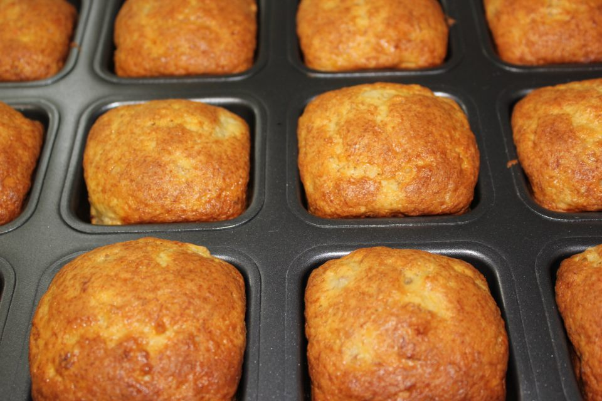
Mini Banana Bread Loaves

1 box Yellow cake mix (don’t follow directions on box!)
2 eggs (beaten)
Ripe bananas (I only had 2 1/2 in the house, so that's what I used—you can use more)

Mix together and use the Large scoop to put the batter in the wells of the Brownie Pan. Bake for about 25 minutes at 350 degrees.
You can also add nuts and chocolate chips to the batter if you desire.

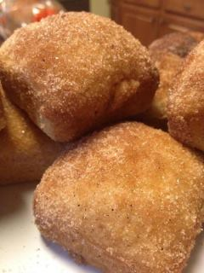
Cinnamon Sugar Loaves

1-¾ cup flour
1-½ teaspoon baking powder
½ teaspoon salt
½ teaspoon nutmeg
½ teaspoon cinnamon
⅓ cup oil
¾ cup granulated sugar
1 egg
¾ cup milk
For the Cinnamon Sugar Topping:
1/4 cup butter, melted
1/3 cup granulated sugar
1 Tablespoon cinnamon
Preheat the oven to 350º. Whisk together the flour, baking powder, salt, nutmeg, and cinnamon in Classic Batter Bowl with Stainless Steel Whisk. In Small Batter Bowl, whisk together oil, sugar, egg and milk. Add dry ingredients and stir only to combine.
Use the Large Stainless Steel Scoop to divide among Brownie Pan wells. Bake at 350 degrees for 15-20 minutes. Remove from pan immediately. Combine sugar and cinnamon. Dip tops into butter then dip into cinnamon sugar. Serve and enjoy. Make sure you save yourself one they will go FAST!

Feta Cheddar and Spinach Muffins

1 ½ cups of plain flour
2 1/2 teaspoons of baking powder
8 oz shredded cheddar cheese
8 oz of chopped feta
½ cup of baby leaf spinach (chopped)
1 egg
1 cup milk
1 teaspoon of cayenne pepper
1 -2 oz of butter melted
half a red onion, chopped
Preheat oven to 350. Melt the butter in a pan, added chopped onion and cook. Add the dry ingredients into a large bowl. In a separate bowl add the egg and milk and whisk; add the egg mixture into the dry ingredients. Chop the spinach finely. Add the onion and spinach into the muffin mixture by hand using a bamboo spoon. Scoop into brownie pan cups. Cook for 30-35 minutes

Green Chili Cheddar Loaves

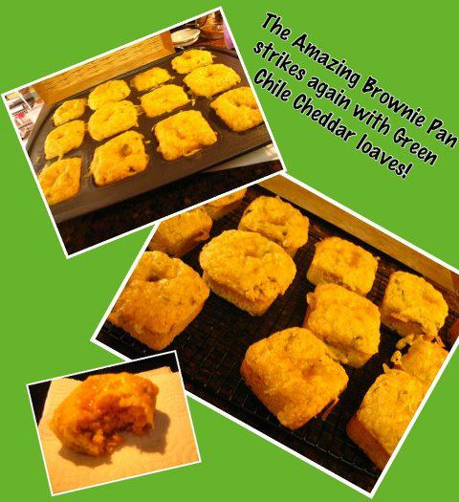
1 cup organic whole white flour (King Arthur)
1 cup cornmeal (used organic cornmeal)
2 Tablespoons Organic sugar
1 teaspoon smoked paprika
1 teaspoon onion powder
2 teaspoons baking powder
1 teaspoon baking soda
1/2 teaspoon salt
1 and 1/4 cups buttermilk
1 large egg
4 Tablespoons unsalted butter, melted
1/2 cup chopped green chiles
1 cup extra sharp cheddar cheese, grated
Preheat oven to 350 degrees F. Spray Brownie Pan with Kitchen Spritzer (used EVOO). Combine dry ingredients. Set aside. In a large bowl, use a wire whisk to combine buttermilk, egg and melted butter. Stir in the flour mixture until just combined. Fold in the green chiles and 1/3 of the cheese.
Fill each opening a little over half full. Bake for 8 minutes. Sprinkle the rest of the cheese evenly over the tops of the loaves. Bake just until a toothpick inserted in the center of the loaves comes out clean (about 8-10 minutes more.) Cool for 10 minutes. Loosen edges and turn out onto a wire rack. Serve warm.

Mexi-Cornbread

1 (8.5 ounce) package corn bread/muffin mix
1 egg
1/3 cup milk
3/4 cup salsa
1 (8.75 ounce) can whole kernel corn, drained
1/2 cup shredded Mexican cheese blend or Cheddar cheese
1/2 cup sour cream
3 bacon strips, cooked and crumbled
2 tablespoons chopped seeded jalapeno pepper*

In a bowl, combine corn bread mix, egg and milk just until blended. Stir in salsa, corn, cheese, sour cream, bacon and jalapeno. Fill brownie pan wells three-fourths full. Bake at 375 degrees F for 15-20 minutes or until a toothpick comes out clean. Cool for 5 minutes before removing from pan to a wire rack. Serve warm.

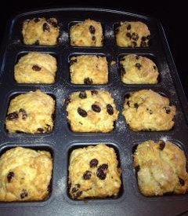
Michele's Mini Irish Soda Breads

2/3 cup raisins (Tip: boil them first so they remain

soft in the bread)
2 C flour
1 1/2 tsp. baking powder
3/4 tsp baking soda
1 tsp salt
3 tbs. sugar
3 tbs. softened butter
1 Cup buttermilk
Additional melted butter and sugar

Blend all ingredients but the additional butter and sugar.
Divide evenly among wells of Brownie Pan.

Drizzle melted butter and sugar on top.

Bake at 325 for about 20 minutes.

Southwest Cornbread

2 boxes Jiffy Cornbread
2 eggs
1 can creamed corn
3/4 c sour cream
1 1/2 tbsp Southwest Seasoning
1 small poblano pepper chopped fine

Mix it all up and use large Stainless Steel Scoop to put heaping scoops into each Brownie Pan well. Bake at 375 for 20-25 minutes. Top with grated cheese as soon as they come out. These freeze great!!!

Busy Mom Puffins (Pancake Muffins)

1 Cup Pancake Mix
2/3 Cup Water
½ cup Syrup

Mix together. Using Medium Scoop, pour in greased Brownie Pan. Top with banana, blueberries, chocolate chips, pecans, sausage, bacon, etc. Bake for 12-14 minutes and serve. Easy, fast, delicious, and no syrup mess!

Mini Monkey Bread
2 can(s) refrigerated buttermilk biscuits
1 c sugar cinnamon mixture
1/2 c butter, melted
SWEET ICING
1/2 c confectioners' sugar
2 Tbsp milk
1 tsp pancake syrup
Directions
1. Open both cans of biscuits and start tearing them into pieces (4 from each biscuit). Preheat oven to 350.
2. In a bowl, put in the pieces of biscuits and sprinkle them with the cinnamon and sugar mixture. You can add as much or as little cinnamon as you like.
3. Melt the butter and pour onto the biscuits. Mix together. Place at least 4 pieces of the mixture into each individual well in the Pampered Chef brownie pan.

4. Bake for 12-15 min. While baking you can make the icing. Simply mix the milk into the confectioner’s sugar add a touch of syrup and stir.
5. Pour the icing onto the Monkey Bread while it’s still warm and ENJOY
BREAKFAST

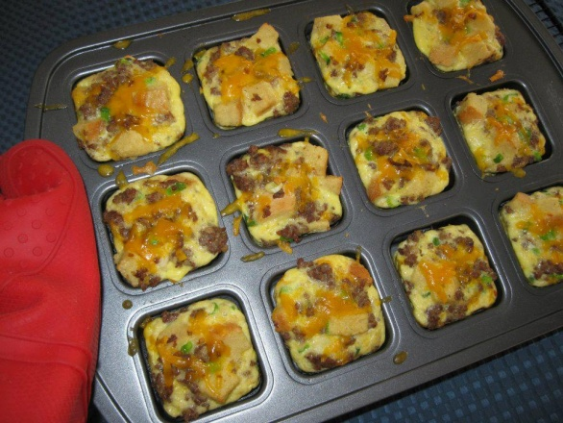
Breakfast Bakes

1 lb sausage, ham or bacon, cooked & drained
9 eggs
½ cup cheese, shredded (cheddar, pepper jack, colby, your choice)
Cubed bread, croutons or frozen hash browns
¼ bell pepper, diced
2 green onions, sliced

Whisk together all ingredients and use the Large Scoop to put one scoopful into the brownie pan. If using hash browns put those directly into the brownie pan first then pour egg mixture on top. Bake at 350 for 17-20 minutes.

Brunch Squares

36 tater tots
1/2 package cream cheese
8 eggs
3 green onions
diced ham or sausage
shredded cheddar cheese
Place three tots in each well. Mix Cream Cheese and eggs in batter bowl. Salt and pepper to taste. Add meat and green onions to egg mixture. Use large Scoop and place 1 scoop of mixture in each well. Bake at 350 for 10-12 minutes. Test with a knife to make sure eggs are set.

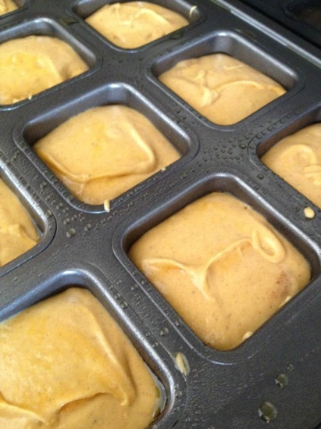
Pumpkin Pancake Muffins (GLUTEN FREE)

Bob Mills gluten free pancake mix in a bag –

follow directions to use the whole bag
Add 2 cups of pumpkin purée with cinnamon and

pumpkin pie spice
Add 2 tsp more each of pumpkin pie spice, nutmeg,

and cinnamon

Blend altogether
23 muffins using large Pampered Chef Scoop

Freeze and use later too!

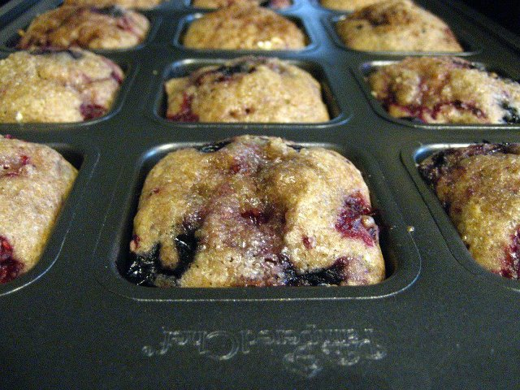
Double Berry Muffin Squares

Ingredients:
1/2 cup butter, softened
1 cup sugar
2 eggs, beaten
1/2 cup milk
2 cups flour 1 wheat/ 1 white
2 teaspoons baking powder
1/2 teaspoon salt
1 teaspoon ground cinnamon
1/4 teaspoon ground nutmeg
3 TBSP ground Flax Seed
2 cups fresh blueberries & raspberries, (may use frozen)
Sweet Cinnamon Sprinkle (From Pampered Pantry, get it before it's gone!!)
Preparation:
Preheat oven to 350 degrees. In a medium mixing bowl, cream together butter and sugar. Add eggs and mix well; stir in milk. Combine dry ingredients and add to the mixture; stir to combine & gently fold in berries. Fill muffin cups about 2/3 full; sprinkle tops with a little Sweet Cinnamon Sprinkle.

Bake for 20 minutes or until lightly browned (cooking time for non-stick darker pan, may need to adjust temp if using another type of pan)
Makes about 12 muffins plus 9 mini muffins -- yum!

German Pancake

Butter | 1/2 c. flour
1/2 c. milk | 3 eggs
Pinch salt | Capful vanilla
Powdered Sugar | Fruit Pie Filling

Preheat oven to 450 degrees. Melt 1/4 T. butter in each well of brownie pan. Whisk in batter bowl: flour, milk, eggs, salt & vanilla; pour equally into 12 wells. Bake about 15 minutes.

Sprinkle with Powdered Sugar and serve with fruit pie filling of your choice!!

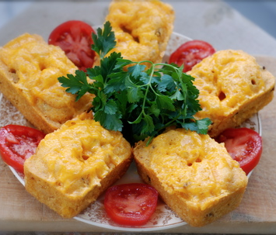
Mini Cheddar Bacon Brunch Loaves

1 cup all-purpose flour

1 cup cornmeal

2 Tablespoons sugar

1 teaspoon smoked paprika

1 teaspoon onion powder

2 teaspoons baking powder

1 teaspoon baking soda

1/2 teaspoon salt

1 and 1/4 cups buttermilk

1 large egg

4 Tablespoons unsalted butter, melted

5 strips of thick-cut bacon, fried and crumbled

1 cup extra sharp cheddar cheese, grated

Preheat oven to 350 degrees F. Butter brownie pan wells. Combine dry ingredients. Set aside. In a large bowl, use a wire whisk to combine buttermilk, egg and melted butter. Stir in the flour mixture until just combined. Fold in the bacon and 1/3 of the cheese.
Fill each opening a little over half full. Bake for 8 minutes. Sprinkle the rest of the cheese evenly over the tops of the loaves. Bake just until a toothpick inserted in the center of the loaves comes out clean (about 8-10 minutes more.) Cool for 10 minutes. Loosen edges and turn out onto a wire rack. Serve warm.

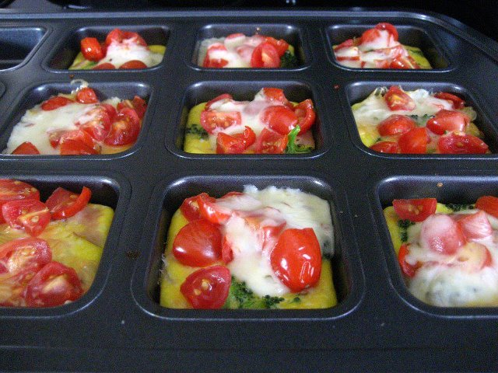

Mini Omelets

1 Dozen eggs

Milk

Toppings of choice: chopped green pepper, onions,

diced ham, mushrooms, tomatoes, etc.

Shredded Cheese (cheddar or swiss)

Whisk eggs & milk (to taste) in Classic batter bowl; pour into the 12 wells then add toppings of choice. Bake 375 for about 17-20 minutes or until set. Flip out of the pan & top with shredded cheese

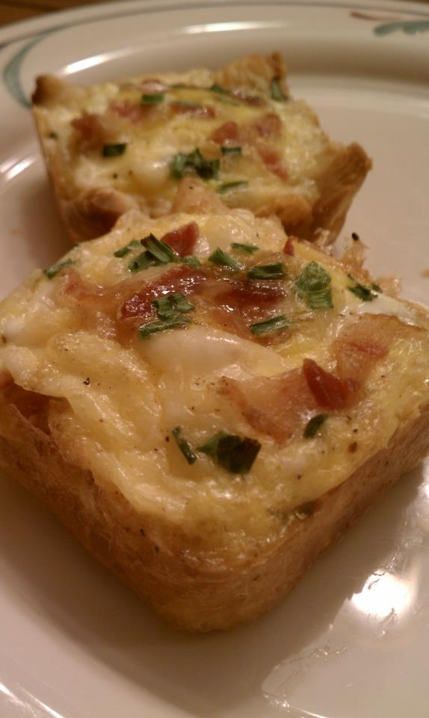
Egg Tarts in the Brownie Pan
Ingredients
• All-purpose flour, for dusting
• 1 1/3 sheets frozen puff pastry (18-ounce package), thawed
• 3 strips bacon
• 1 cup shredded havarti cheese
• 3 tablespoons shredded parmesan cheese
• 4 - 5 large eggs
• Kosher salt and freshly ground pepper
• Chopped fresh chives, for topping
Directions
Preheat the oven to 400 degrees F and use the Kitchen Spritzer to lightly grease the Brownie Pan with vegetable oil. Open one puff pastry sheet on a lightly floured Pastry Mat or Flexible Cutting Mat. Use the Pizza Cutter to slice the sheet into nine equal squares, then cut 1/3 of the second sheet in the box apart for the remaining 3 squares needed to fill all 12 wells. Fit into the Brownie Pan and use the Hold ‘n Slice to prick all over the sides and bottom of each. Bake until golden, approximately 10 minutes.
Meanwhile, use the Microplane Adjustable Coarse Grater to shred the havarti cheese and the Fine Grater for the parmesan. Microwave the bacon in the Small Ridged Baker, covered with Parchment Paper, for approximately 4-5 minutes. Use the Mini Professional shears to snip the bacon into bits, and to cut the chives into a 1 cup Prep Bowl. Break the eggs into the Classic Batter Bowl, beat with Stainless Whisk, and season with salt and pepper.
Let the tart shells partially cool in the pan on the Stackable Cooling Rack. If the centers are very puffy, prick with a fork to deflate. Sprinkle evenly with the havarti and parmesan cheeses. Make a shallow well in the cheese in the center of each tart and use the Medium Scoop to pour egg into each. Top with the bacon, then return to the oven and bake until eggs are set, approximately 12 more minutes. Top with chives.

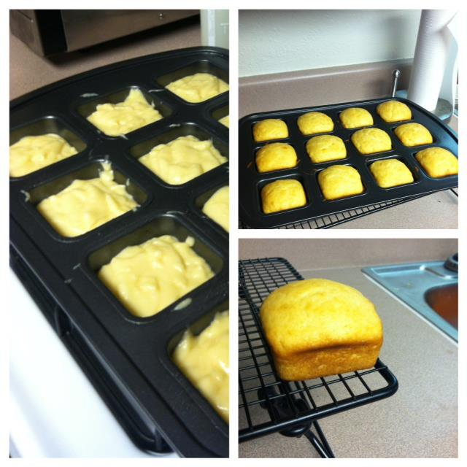
BROWNIES & CAKES

Almond Pound Cake

2 sticks butter, softened
6 eggs, room temperature
3 c. sugar
3 c. flour
¼ tsp baking soda
1 c. sour cream
1 ½ tsp almond extract (lemon or vanilla can be substituted)

Mix all ingredients together with an electric mixer. Spray brownie pan and drop 1 Large Scoop into each well. Bake at 350 for 30-35 minutes.

Recipe makes more than 12, great to freeze! To lighten this recipe up, use LIGHT butter & Splenda.

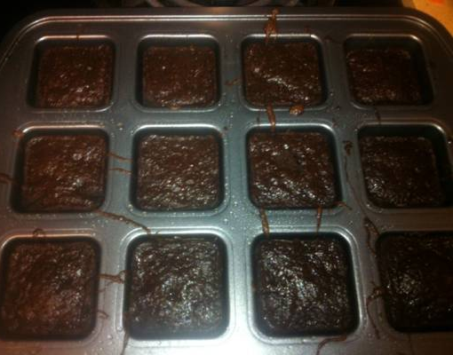
Brownies – GLUTEN FREE

1 box of gluten free brownie mix (dry mix only)

2 tsp. of vanilla (optional)
2 table spoons of water
6 oz of plain Greek yogurt

Mix ingredients together and bake at 325 for approximately 20 minutes. Just 18 calories & 2 grams of fat per brownie!

Brownies – Healthier (Weight Watchers ~4 points)

1 can solid pack pumpkin

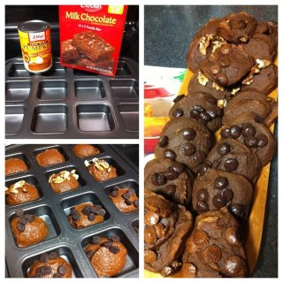
1 box brownie mix

Optional - candy toppings, nuts or chocolate chips

Mix together pumpkin and brownie mix and divide into

brownie pan wells. Bake at 400 for 20 mins.

If desired, add optional toppings.

4 points a brownie without candy toppings! Enjoy :)

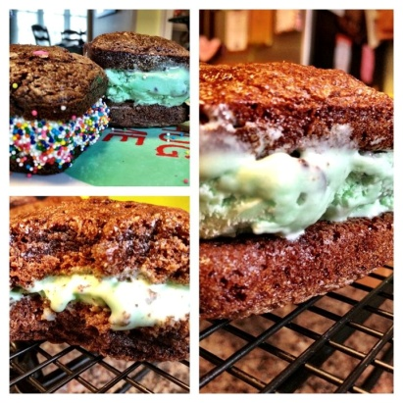
Brownies – Ice Cream Sandwiches

1 box of brownie mix, plus ingredients to prepare -OR-
1 batch of WW Brownies (recipe pg 12)
Ice Cream – OR – Frosting
Toppings of choice - Sprinkles, chocolate chips, coconut, etc

Prepare brownie mix OR WW Healthy Brownies according to
directions.
Bake at 325 for approximately 20 minutes, or until done. To serve, slice brownies in half horizontally and scoop 1 medium scoop of ice cream or frosting onto one half; top with remaining brownie half. For a larger version use TWO brownies (don’t split) and use one Large scoop of filling. Once assembled, roll in toppings of choice.

Cinnamon Pecan Blondie Bars
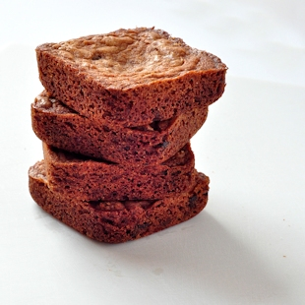

4 oz butter
1 cup brown sugar
1 egg
1 tsp vanilla
1 ¼ cups All-purpose flour
1 tsp baking powder
½ tsp salt
1 ½ tsp ground cinnamon
½ cup chopped bittersweet chocolate (or choc. chips)
½ cup chopped, toasted pecans

Preheat oven to 350 degrees. Use Baker’s Joy and spray the brownie pan wells. Wipe off excess spray that gets on the top of the pan.

Melt butter in Large Batter Bowl. Stir in brown sugar until well blended. Mix in the egg and vanilla until it’s very smooth. Next, add flour, baking powder, salt, and cinnamon; mix just until combined. Then add chocolate chips/chopped chocolate. Next, add pecans; mix just until combined and divide evenly in the brownie pan. (Should make about 18 bars.)

Bake at 350 for 18-20 minutes. They should be nicely browned across the top and a toothpick inserted should, at most, have just a few moist crumbs on it.

*These will keep in a sealed container for a week or so and they do freeze well.

Brownies – Peanut Butter & Jelly Sandwiches

1 cup semi-sweet chocolate morsels, divided
1 pouch (10.25 oz) fudge brownie mix (see Cook’s tip)
½ cup all-purpose flour
2 eggs
½ cup canola oil
¼ cup water
½ cup powdered sugar
1/3 cup creamy peanut butter
¼ cup butter (1/2 stick) softened
¼ cup seedless raspberry jam
2 tbsp. dry-roasted peanuts

- Preheat oven to 350* F. Line Stackable Cooling Rack with Parchment Paper. Place ½ cup of the chocolate morsels in 1 cup Prep Bowl; microwave uncovered, on HIGH 1 minute or until mostly melted, stirring every 20 seconds. Combine brownie mix, flour, eggs, oil, water and melted chocolate in Classic Batter Bowl; whisk until smooth. Using Large Scoop, divide batter evenly into wells of pan. Bake 14-17 minutes or until wooden pick inserted into centers of brownies comes out clean.
- Meanwhile, for filling, combine powdered sugar, peanut butter, and butter in Manual Food Processor; cover and pump handle until smooth, scraping down sides as necessary. Spoon filling into small resealable plastic bag; secure and set aside.
- Spoon jam into Decorator Bottle fitted with round tip. Chop peanuts using Food Chopper. Place remaining ½ cup chocolate morsels in same prep bowl. Microwave, uncovered, on HIGH 1 minute or until mostly melted, stirring every 20 seconds. Spoon melted chocolate into small resealable plastic bag; secure and set aside.
- Remove pan from oven. Let brownies cool for a few minutes, then invert parchment-lined cooking rack over pan; flip over and remove pan. Slice brownies horizontally in half using Color Coated Bread Knife. Place brownie bottoms onto serving platter. Distribute filling evenly over brownie bottoms. Top with jam and brownie tops. Drizzle chocolate over sandwiches; top with peanuts.

Yield: 12 servings
U.S. Nutrients per serving (1 sandwich): Calories 410, Total Fat 25g, Saturated Fat 7g, Cholesterol 40 mg, Sodium 160 mg, Carbohydrate 43 g, Fiber 2 g, Protein 5g

Cook’s Tip: If desired, 2 cups plus 2 tbsp of fudge brownie mix from an 18-oz package can be used for this recipe.

Brownies – Reese's Cup Cookie

1 pkg Chocolate Chip Cookie Dough
(24 count pop & bake or 1 roll refrigerated
12 Mini Reese’s Cups
Brownie Mix & ingredients

Mix the brownies as directed. Place 2 cookies or a scoop of chocolate chip cookie dough on bottom of each well and push down with Tart Shaper or your fingers. Next, place a small Reese’s cup placed upside down on the cookie dough. Using a Medium Scoop – drop brownie mix on top of Reese's cup. Bake at 350 for about 16-20 minutes. (Until brownie is done) Immediately flip onto Stackable Cooling Rack.

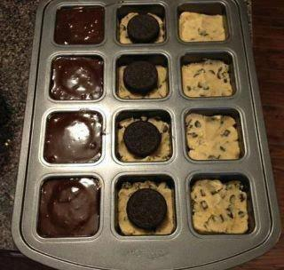
Brownies – Triple Layer

1 pkg Chocolate Chip Cookie Dough
(24 count pop & bake or 1 roll refrigerated)
12 Oreo Cookies
½ box of Brownie Mix + ingredients to make
Spray brownie pan with nonstick baking spray with flour.
Mix ½ package of brownie mix according to package directions.
Place 2 squares of cookie dough (or 2 Small Scoops of dough if using
roll) in the bottom of each brownie well, press down evenly.
Top with 1 Oreo cookie + 1 Medium Scoop of brownie mix.
Bake at 350 for approximately 20 minutes.

Brownies – Turtle Fudge

Brownie Mix and ingredients
3 packages of Rolos

Mix brownies as directed and fill each well of brownie pan with brownie mix. Cut each Rolo in half. Place 4 rolo halves on top of each brownie square. Sprinkle with chopped pecans. Bake at 325 for 23 mins. Remove from pan and drizzle with melted chocolate.

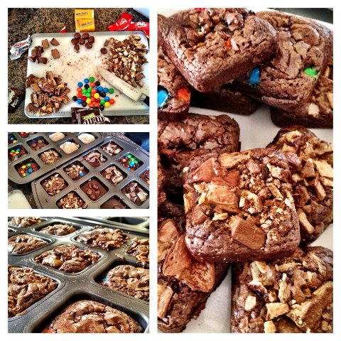

Chocolate Chip Cookie Sensation
1 ½ tubes of refrigerated chocolate chip cookie dough
2 regular size Snickers bars, chopped
½ cup chopped pecans
½ cup chocolate chips
Caramel ice cream topping (optional)
Ice cream (optional)
Place small scoops of chocolate chip cookie dough on bottom – push down with Tart Shaper (or your fingers). Chop 2 regular size Snickers candy bars and place on cookie dough. Sprinkle with chopped pecans and chocolate chips. Bake 350 for 20-22 mins. Top with ice cream and caramel ice cream topping if desired.

German Chocolate Whoopie Pies
1 German Chocolate cake Mix, plus ingredients to make
1 cup sugar
1/4 tsp salt
3/4 c evaporated milk
2 egg yolks
3/4 t vanilla
3/4 cup butter (1 1/2 Sticks)
2 cups toasted coconut
2 cups toasted pecan halves, finely chopped.

Mix cake mix per box directions; use medium scoop and fill brownie pan wells. I spray my wells with spray that has flour in it. Bake 12-14 minutes till cake bounces back to touch.

Combine sugar and salt in 2 qt sauce pan. Gradually whisk in evaporated milk, egg yolks, and vanilla. Add butter cook over medium heat stirring constantly, 8-10 minutes or until temp reaches 160. Pour into batter bowl and add coconut and pecans. Slice cake in half and then add filling to center. You can drizzle a little chocolate on the top with extra coconut and pecans!

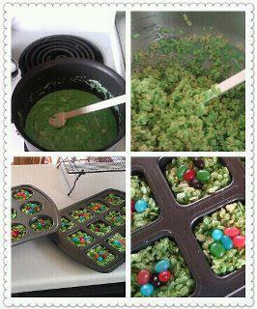
Easter-Time Rice Krispie Treats

Follow directions for Rice Krispie Treats add green food coloring
and top with Jelly Beans

Key Lime Cupcakes

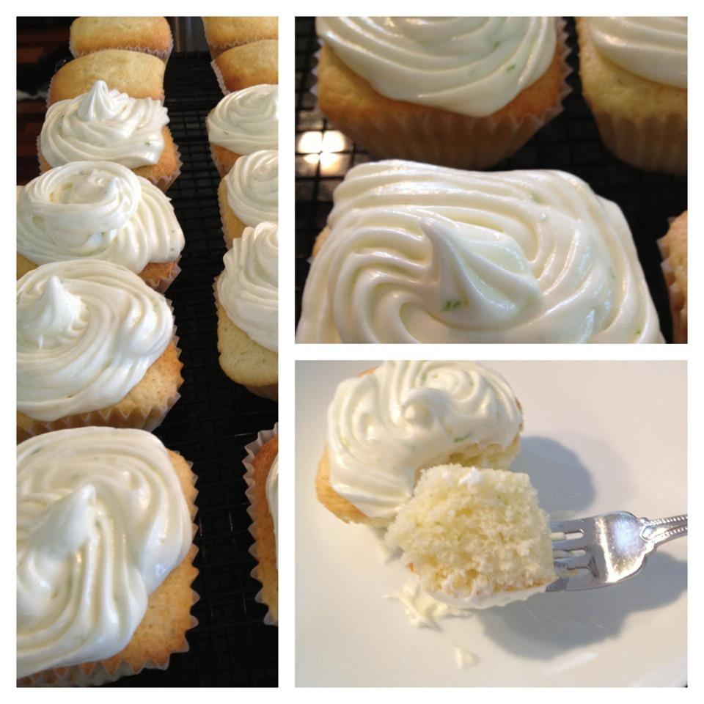
1 ¾ cups cake flour
½ teaspoon baking powder
½ teaspoon baking soda
½ teaspoon salt
1 stick (1/2 cup) cold unsalted butter, cut into 8 pieces
1 ¼ cups granulated sugar
2 large eggs (room temperature)
2 ½ tablespoons key lime juice
1 tablespoon key lime zest
1 drop green food coloring paste (optional)
¾ cup buttermilk (room temperature)

Icing:
1 stick cool unsalted butter, cut into 8 pieces
8 ounces cream cheese, softened, cut into 8 pieces
2 ¼ cups powdered sugar, sifted
1 tablespoon key lime zest

Preheat oven to 350 degrees F. Line each brownie well with a paper liner (a round one will shape to the square well when filled). Sift the cake flour, baking powder, baking soda and salt three times; set aside.
Using a mixer fitted with the paddle attachment, beat the butter on low until its softened a bit. Add the sugar and increase the speed to medium. Beat until fluffy, about four minutes. Add one egg at a time, beating well after each addition. Add the lime juice, zest, and food coloring and beat until well mixed. (The mixture will look curdled).

Add the flour in three additions, alternating with the buttermilk, beginning and ending with the flour, scraping down the bowl as necessary. Mix on low until combined. Fill each cupcake liner 2/3 full. Bake 20-25 minutes. Cool completely and frost with cream cheese icing.

Icing:
Using a mixer fitted with the paddle attachment, beat the butter on low until it’s a bit softened. Increase speed to medium and add the cream cheese one piece at a time. Reduce speed to low and slowly add powdered sugar until combined. Beat in zest.

Cupcakes

½ of a standard cake mix (1 ¾ c)
¼ cup oil
1 egg
½ cup water
Mix and scoop into wells. Bake at 350 for 12 minutes. Perfect amount to fill pan with one batch.
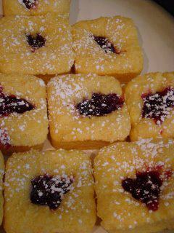

Lemon Raspberry Mini Cakes

1 pkg (15.25 oz) Yellow Cake Mix
5 TBSP Melted Butter
1 Large Lemon
1 container (8oz) Sour Cream
1 Egg
1 can (12oz) Raspberry Cake and Pastry Filling
Powder Sugar for dusting

- Preheat oven to 325 degrees
- Pour cake mix into Classic Batter Bowl. Zest whole lemon into the mix and stir. Juice the lemon with juicer to measure 1/4 cup. Add juice, sour cream, egg and melted butter to the cake mix and zest and mix until smooth. The batter will be thick but if it is too thick add a TBSP of more juice or water.
- Using Large Scoop, put one scoop of batter into each well of the brownie pan. Use your fingers to spread to the edges. Take a small scoop of raspberry pastry filling and put in the center. Bake for 15 minutes or until toothpick inserted in center comes out clean.
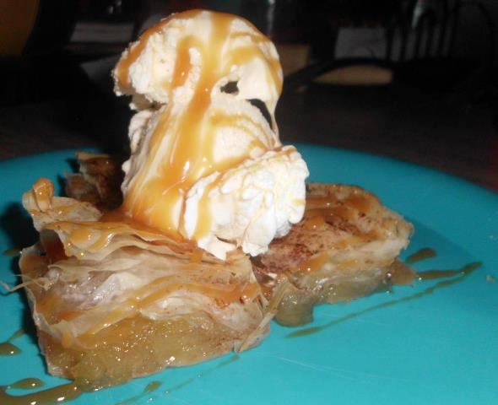
- Cool slightly then sprinkle with powdered sugar

Phyllo Apple Squares

1/2 package of premade Phyllo dough sheets
(thawed, cut in squares to fit brownie pan)
1 can Trader Joes Apple Pie filling (or make your own)
1/4 c. melted butter
Cinnamon to taste
Optional: Caramel sauce or vanilla ice cream
Use the PC food processor or chopper to chop the apple pie filling into small bits. Set aside. Place one square of Phyllo dough at the bottom of each square in the pan. Use a pastry brush to brush with melted butter. Repeat three layers deep. Add a heaping tablespoon of minced apple pie filling and sprinkle with cinnamon. Layer three more Phyllo sheets on top and sprinkle with more cinnamon if desired. Bake at 350 for 12-15 minutes, or until browned. Serve with caramel sauce drizzle or ice cream or BOTH!
(Remember to cover the unused Phyllo sheets with a damp paper towel while preparing this recipe, the dough dries out very quickly!)

Pineapple Upside Down Cake
Individual Pineapple Upside-Down Cakes
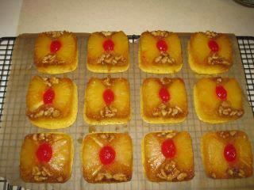
(Based on The Pampered Chef’s recipe in Delightful Desserts, p. 58)
Ingredients:
½ cup of butter
1 cup of packed brown sugar
12 maraschino cherries, halved
One 20-oz. can of pineapple rings with juice
½ cup of walnuts, coarsely chopped
3 eggs
One box of yellow cake mix (18.25 oz. size)
1/3 cup oil
1) Preheat oven to 325 F. Open a can of pineapple rings and drain liquid into 2-Cup Easy Read Measuring Cup using Can Strainer. Add enough water to pineapple liquid to make 1 1/3 cups of liquid. Set aside. Cut pineapple rings into quarters.
2) In Small Batter Bowl, melt butter. Mix in brown sugar. Using Small Stainless Scoop, portion a scant scoop of sugar mixture into each well of two Brownie Pans. Spread to cover bottoms of wells with Skinny Scraper.
3) Add two pieces of the quartered pineapple rings to each well of Brownie Pan. Place one maraschino cherry half in the center of each well. Sprinkle chopped nuts evenly over pineapple slices in pans
4) Combine cake mix, pineapple liquid, eggs, and oil in 4-Qt. Stainless Mixing Bowl. Whisk until well blended. Using Large Stainless Scoop, portion batter into wells of Brownie Pan, filling each well 2/3rds full.
5) Bake cakes for 20-22 minutes until toothpick inserted in center of cakes comes out clean. Cool in pan for 3 minutes, then invert onto parchment-lined Stackable Cooling Rack. Serve warm with whipped topping, if desired. Makes 24 individual cakes. NOTE: Recipe may be halved to fill just one Brownie Pan and make 12 servings. Use a small cake mix (like Jiffy brand) or 1 2/3 cups of dry cake mix, 2 eggs, and 2/3 cup of pineapple liquid, plus 2 T. oil. Use half the butter, sugar, pineapple and cherries
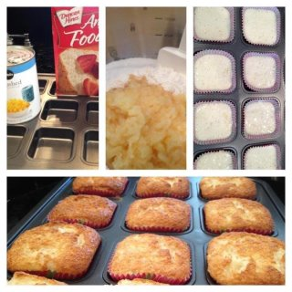
Pineapple Angel Loaves

(Weight Watchers ~ 1 Point)

1 angel food cake mix
1 lg can crushed pineapple
Line Brownie Pan with cupcake liners (regular cupcake liners will go
square when filled). Mix ingredients thoroughly in Classic Batter Bowl
with Mix and Masher. Fill each well using the Large Scoop and
bake at 350 for 15 minutes.

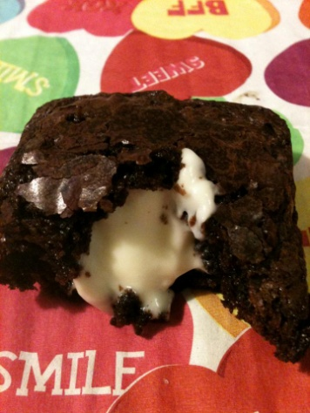
Note: This makes 24 cupcakes but you need to do both pans at the
same time. If the batter sits too long it goes flat and icky.
Cream Cheese Filled Brownies

Cream Cheese Filling:
8 oz cream cheese
2 T butter, softened
1 cup powdered sugar
1 tsp vanilla

Bake plain brownies of your choice.
Mix together Cream Cheese Filling. Remove brownies from Brownie Pan. While brownies are still warm, make a slit in the side of them. Use the Easy Accent Decorator, Decorator Bottle Set, or Wilton tip #230 to fill cream cheese mixture into the brownies. If the brownies are really soft, it may not be necessary to make a slit in them. Watch the tops and bottoms of the brownie as you fill it; you will see it grow as it gets full, so you’ll know when it’s filled enough. Keep leftover brownies refrigerated.

Cream Cheese Pound Cake
3/4 cup butter, softened
1 pkg. (8 oz.) cream cheese softened
1 1/2 cups sugar
4 eggs
1 1/2 teaspoon vanilla
2 cups flour
1 1/2 teaspoon baking powder

Preheat oven to 350*. Spray brownie pan. Cream butter, cream cheese and sugar until light and fluffy. Add eggs and vanilla. Beat on low speed until blended. Sift together flour and baking powder. Gradually add to butter mixture, beating until combined. Drop 1 large scoop into each well. Bake 350 for 30-35 minutes.

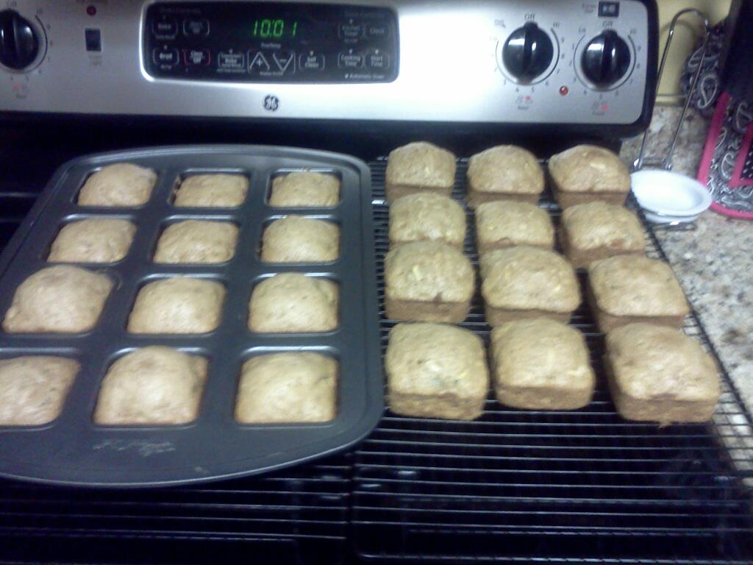
Zucchini “Brownies” Bread
3 eggs (beaten)
1 cup oil
1 tbls vanilla
2 cups sugar
1 ½ tsp ground PC Korjinte Cinnamon)
1 tsp baking soda
1 tsp salt
¼ tsp baking powder
2 cups grated zucchini
3 cups flour

Beat eggs, add oil, blend; add sugar and vanilla; add dry ingredients except flour; next add grated zucchini; gradually add flour mixing well.
I sprayed the brownie wells lightly with my kitchen spritzer that I have filled with olive oil; I filled the wells evenly in two brownie pans
Bake at 350 degrees for about 20 minutes (I checked them for doneness after fifteen minutes)
Makes 24 zucchini “brownies”

Two Ingredient Lemon Bars

It has a melt in your mouth spongy texture like they are cut from the middle of a pie!
Ingredients:
1 box Betty Crocker angel food cake mix
2 - 21 oz. cans of Comstock pie filling (total of 42 oz.)
Directions:
- In large bowl with Stainless/Silicone Batter Whisk, mix dry cake mix and cans of pie filling together in large bowl, until smooth.
- Fill the Brownie Pan wells 2/3 full. Since the pan is a dark, easy release, you do not have to oil or flour the pan.
- Bake at 350 degrees for 20-25 minutes on the middle rack. When done, top edges will start to brown around the edges.
- Place Stackable Cooling Rack on the top of the Brownie Pan and flip over. The lemon bars will drop out. If one or two are a little sticky just shake the pan a little.
- Sprinkle with powdered sugar.
Note: If you over bake, they will adhere to the wells.

Red Velvet Cheesecake Brownies
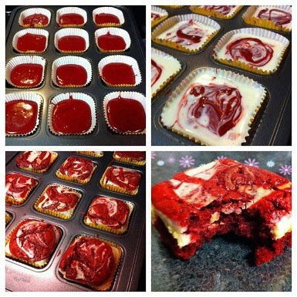
Ingredients:
1/2 cup butter
2-oz dark chocolate, coarsely chopped
1 cup sugar
2 large eggs
1 tsp vanilla extract
1 1/2 tsp red food coloring
2/3 cup all-purpose flour
1/4 tsp salt 8-oz cream cheese, room temperature
1/3 cup sugar
1 large egg
1/2 tsp vanilla extract

Directions:
Preheat oven to 350F. Line one brownie pan/cupcake tin with cupcake liners In small bowl, melt (microwave) butter and chocolate together in 30 second increments. Stir until combined and very smooth. Set aside to cool for a few minutes. In a large bowl, whisk together sugar, eggs, vanilla extract and red food coloring. Add chocolate mixture and stir until smooth. Add flour and salt and stir until just combined and no streaks of dry ingredients remain. Pour batter into lined wells. To prepare cheesecake mixture, beat cream cheese, sugar, egg and vanilla extract in a medium bowl until smooth. Distribute the cheesecake mixture over batter in the pan. Swirl in with a knife or spatula. Bake for 20-25 minutes, until brownies and cheesecake are set. A knife inserted into the cheesecake mixture should come out clean and the edges will be lightly browned. Let cool completely in pan.

Pudding Chip Bar Cookies

Ingredients:
2 sticks unsalted butter | 3/4 cup packed brown sugar | 1/4 cup sugar
1 4 oz. pkg. vanilla instant pudding | 2 c. chocolate chips, milk chocolate | 1 tsp. vanilla extract
2 1/2 c. All-Purpose flour | 2 eggs | 1 tsp. baking soda

Instructions:
Preheat oven 325 degrees. Cream butter and sugars in mixing bowl until light and fluffy, add pudding, eggs and vanilla. Beat well. Mix in flour and baking soda, then fold in chocolate chips. Use PC large scoop and spray brownie pan. Press the dough into pan just slightly, then bake two pans at a time for 15-17 mins. If you have a convection oven, bake for 14 mins then turn on convection and bake an additional 3 mins. Perfect every time! Yield : 2 doz.

S'mores Brownie Bites
Adapted from:lovintheoven.com

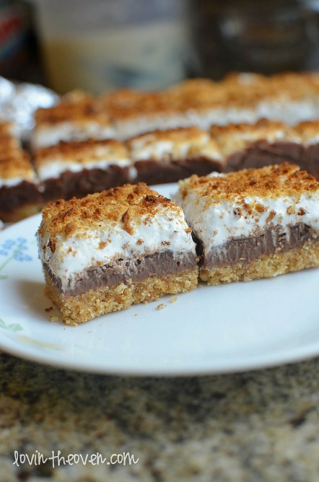
Ingredients:
2 cups graham cracker crumbs
½ cup butter, melted
¼ cup granulated sugar
½ tsp salt

Fudge Layer:
2 cups milk chocolate chips
14 oz sweetened condensed milk

Fluff Layer:
1 jar of marshmallow fluff/creme
Directions:

1. Preheat oven to 350°
2. Line each well with 2 small pieces of aluminum foil or parchment paper, in a cross pattern so that you can easily lift each s’more out of the well.
3. In a large bowl, mix all the ingredients for your crust together press into the bottom of each well of the brownie pan.
4. Bake for 10 minutes. Remove from oven and set aside.
5. In a medium pan over low heat, melt together the milk chocolate and condensed milk. Immediately pour over the crust, filling each well
6. Spread about 1½ 2 cups of the marshmallow fluff on top of the chocolate layer.
7. Put the pan in the oven and broil for 3045 seconds

Optional: Sprinkle graham cracker crumbs on top of the marshmallow before broiling.

Note: The crust should be 1/3, the chocolate layer should be 1/3 and the marshmallow layer should be 1/3.
MAIN DISH/ ENTREE

Broccoli-Chicken Cups Recipe

2 cups (8 ounces) shredded cheddar cheese, divided
1-1/3 cups crisp rice cereal
1 cup cubed cooked chicken
2 tubes (10 ounces each) refrigerated biscuits
1 can (10-3/4 ounces) condensed cream of mushroom soup, undiluted
3 cups frozen chopped broccoli, cooked and drained
Seasonings of choice (try southwest, herbs de Provence, Italian or parmesan garlic!)

Place biscuits in greased brownie pan, pressing dough onto the bottom and up the sides. Add 1 tablespoon cheese and cereal to each cup. In a large bowl, combine the chicken, soup and broccoli; spoon into each well. Bake at 375° for 20-25 minutes or until bubbly. Sprinkle with remaining cheese.

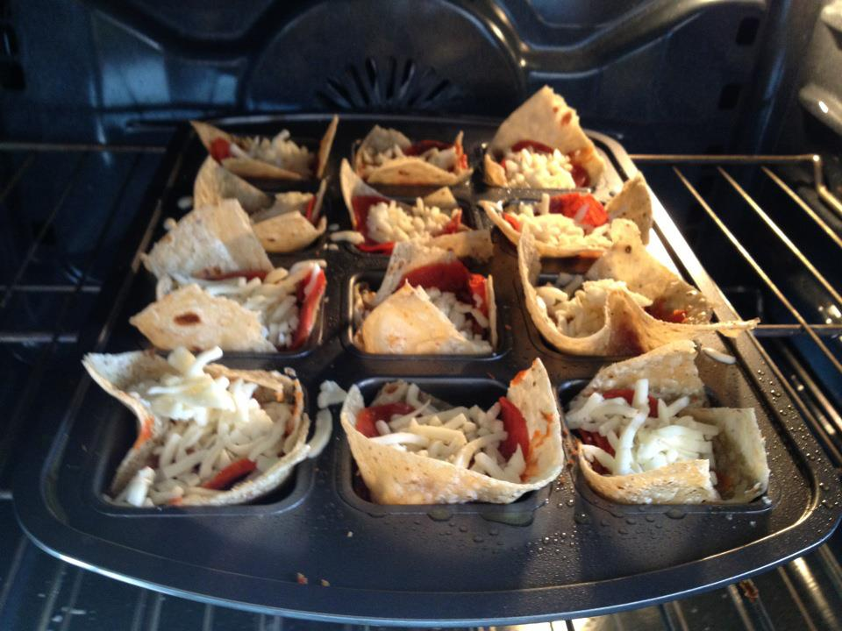
Pizza Cups

1/4 Brown rice tortilla
1/4 spoon of pizza sauce
4 pepperoni
Pinch of mozzarella
Bake at 325 degrees for about 8 min—
depending on how crispy you like the tortillas.
Only 99 cal per cup!

Chicken Jalapeño Cornbread Bake

2 packages (8.5 ounces each) cornbread mix plus ingredients for cornbread
1 1/2 cups chopped cooked chicken
1/2 cup (2 ounces) grated cheddar cheese
1 jalapeño pepper, seeded and chopped
2 tablespoons Southwestern Seasoning Mix

Directions: Preheat oven to 350°F. Spray one Torte Pan with nonstick cooking spray. Combine ingredients for cornbread according to package directions in Classic Batter Bowl; add chicken, cheese, jalapeño pepper and seasoning mix. Mix well. Pour batter into prepared pan; bake 20-22 minutes or until wooden pick inserted into center comes out clean. Remove from oven; serve warm.

Lemon Herb Chicken Bites
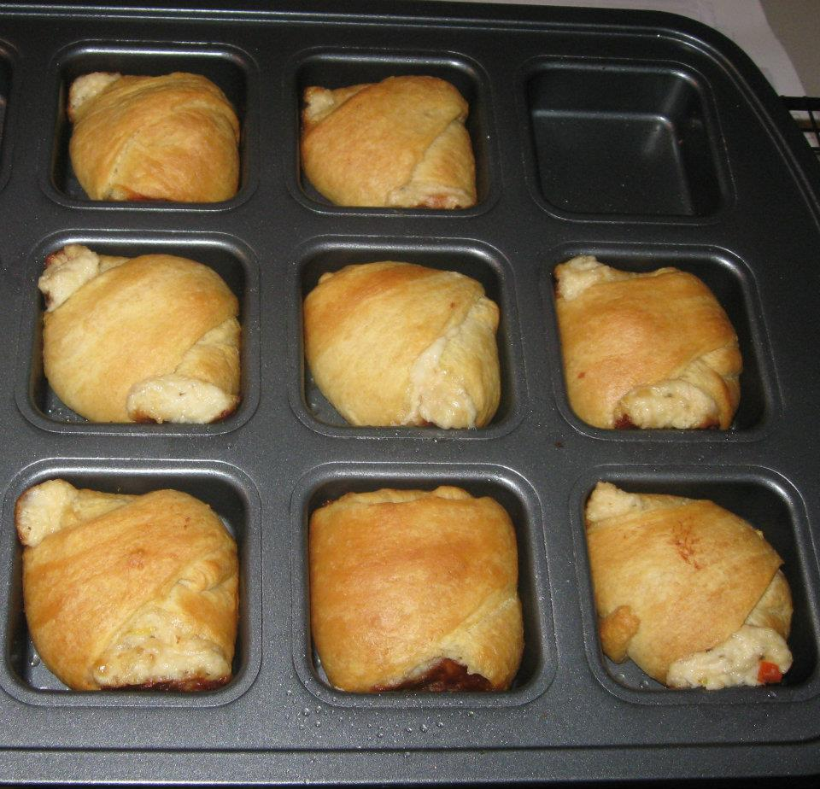
2 cups coarsely chopped cooked chicken (about 12 ounces)
½ cup diced red bell pepper
2 Tablespoons chopped fresh parsley, divided
(optional)
1 lemon
2 garlic cloves, pressed
1 cup (4oz) shredded mozzarella cheese
½ cup mayonnaise
1 teaspoon Pampered Chef Italian Seasoning Mix
½ cup (2oz) grated fresh Parmesan cheese, divided
3 packages (8 each) refrigerated crescent rolls
(makes 24)

-Preheat oven to 350°F.
-Coarsely chop chicken using Food Chopper.
-Dice bell pepper on Cutting Board using Utility Knife.
-Place chicken and bell pepper in Classic Batter Bowl.
-Mince parsley using Pizza Cutter.
-Zest lemon using Lemon Zester/Scorer to measure 1 teaspoon zest
-Measure ½ cup of mayonnaise using Measure All Cup.
-Add 2 Tablespoons of the parsley, lemon zest, and garlic pressed with Garlic Press, mozzarella cheese, mayonnaise and seasoning mix to batter bowl; mix using Small Mix ‘N Scraper.
-Grate Parmesan cheese using Cheese Grater. Add to chicken mixture; mix well.
-Grease your Brownie Pan with cooking spray or oil from Kitchen Spritzer
-Unroll crescent rolls; separate into 24 triangles.
-Use Baker’s Roller to flatten if necessary.
-Arrange each triangle diagonal in each square of Brownie Pan.
-Using Medium Scoop, place one scoop of chicken mixture in the middle of triangle.
-Bring points of triangles up over filling and then use last point to cover and tuck underneath.
(Filling may show a little)
-Bake 15-20 minutes or until golden brown. Yields 24 squares.
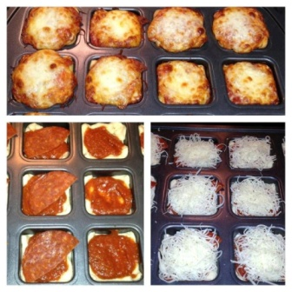
Deep Dish Pizza
This recipe is SO easy to adjust and make your own!

1 pkg Pillsbury Pizza Crust
1 pkg turkey breakfast sausage patties
1/2 can black olives, drained
1/2 jar spaghetti sauce
12 ounces part skim mozzarella, shredded

Using Bakers Roller, roll out Pizza Crust on Large Cutting board and cut into 12 squares; place in Brownie Pan wells. Cook sausage patties on Small Ridged Baker in microwave, crumble with Mix N Chop. Chop olives using Food Chopper. Grate mozzarella cheese using Microplane Grater.

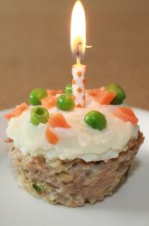
Layer sausage & olives on top of pizza crust. Using Medium Scoop, place one scoop of spaghetti sauce on top of sausage. Sprinkle shredded cheese liberally on top. Bake at 375F for 15-20 minutes or until squares in the center are done!

Healthy Dinner “Cupcakes”
Recipe adapted from education.com

Vegetable oil | ½ pound ground turkey | ½ cup zucchini, grated
1/3 cup onions, finely chopped | ¼ cup breadcrumbs | 1 egg white
½ teaspoon salt | ¼ teaspoon garlic powder | 1 cup mashed potatoes
¼ cup carrots, cooked & finely chopped | ¼ cup cooked peas

Preheat oven to 400 degrees. Combine the turkey, zucchini, onions, breadcrumbs, egg white, salt, and garlic powder together and mix well to form a meatloaf mixture. Lightly grease the wells of the Brownie Pan with vegetable oil. Spoon the turkey mixture into the wells of the Brownie Pan so that each tin is filled to the top but not overflowing. Smooth with a spoon so the tops are flat.
Place the turkey cupcakes in the oven and bake until the internal temperature reads 165 degrees, about 20-25 minutes. Remove the cupcakes from the oven and let cool for a few minutes, and then carefully remove them from the pan. You may want to use a knife or spatula to gently loosen them before removing them.
Arrange the cupcakes on a plate and "frost" them with the mashed potatoes. Finish the cupcakes by scattering carrot and pea "sprinkles" on top for decoration.

Individual Meatloaf

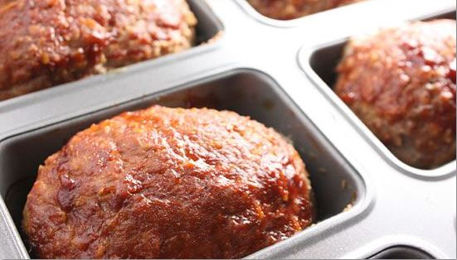

3 tablespoons olive oil  2 garlic cloves, minced  1 cup finely diced white onion  1 tablespoon dried basil  1 tablespoon dried thyme  1 tablespoon dried oregano  2 large eggs  ¼ cup finely diced green bell pepper (OPTIONAL) | ½ cup skim milk  1 cup plain whole oats  1 lb. ground beef  1 lb. ground turkey  ½ tablespoon salt  ½ tablespoon freshly ground black pepper  ¼ cup Worcestershire sauce  ½ cup canned diced tomatoes, drained
½ cup ketchup mixed with a little brown sugar or just canned diced tomatoes, for topping
Preheat oven to 325*. In a large saute’ pan on medium heat, warm the olive oil, then add the garlic, onion, bell pepper, basil, thyme, and oregano. Saute the vegetables for 3 to 4 minutes, until they begin to soften.

In a bowl, whisk together the eggs and milk; add the oats. In a large bowl, combine the meats well by hand; season with the salt and pepper. Pour the liquid mixture over the blended meats and mix thoroughly to combine. Add the Worcestershire sauce, tomatoes and sautéed vegetables. Mix well.

Place the mixture in brownie pan. Spread the ketchup mixed with a little brown sugar or diced tomatoes evenly on top of the loaf. Bake 325* for 20 minutes!

Remove from the oven and allow to cool for 2-3 minutes before serving. Makes 2 brownie pans full.

Mini Corn Dog Nuggets

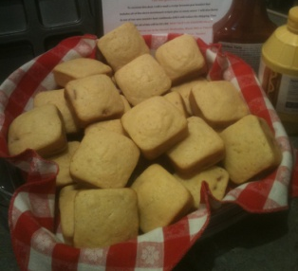
Make your corn bread like normal, scoop into the wells and drop sliced hot dog into each. Bake and BAM!! Kids have a hand held meal!! Or you could use croissants and wrap them.. If you don’t do hot dogs you could substitute CHICKEN!!

Impossibly Easy Cheeseburger Pies

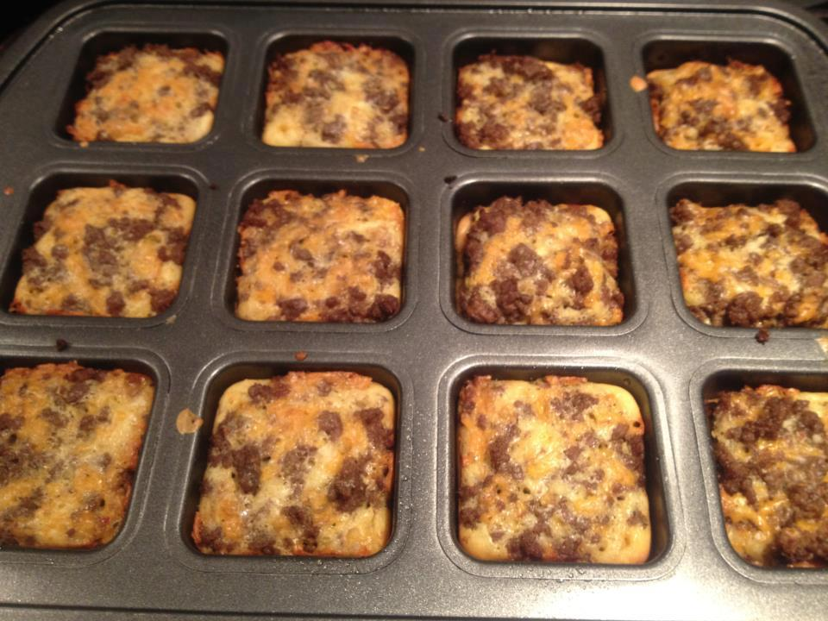
Burger Mixture
1 lb lean (at least 80%) ground beef
1 large onion, chopped (1 cup)
1 tablespoon Worcestershire sauce
1 teaspoon garlic salt
1 cup shredded Cheddar cheese (4oz)

Baking Mixture
1/2 cup milk
1/2 cup Original Bisquick® mix
2 eggs

Garnishes, if desired 12 mini kosher dill pickles, medium tomato, chopped
Ketchup and mustard

Heat oven to 325°F. Spray 12 brownie pan wells with cooking spray. In 10-inch skillet, cook beef and onion over medium-high heat 5 to 7 minutes, stirring frequently, until thoroughly cooked; drain. Cool 5 minutes; stir in Worcestershire sauce, garlic salt and cheese.

In medium bowl, stir baking mixture ingredients with whisk or fork until blended. Spoon 1 scant tablespoon baking mixture into each well. Top with about 1/4 cup burger mixture. Spoon 1 tablespoon baking mixture onto burger mixture in each muffin cup.

Bake about 20-25 minutes or until toothpick inserted in center comes out clean, and tops are golden brown. Cool 5 minutes. With thin knife, loosen sides from pan; remove from pan and place top side up on cooling rack. Cool 10 minutes longer, and serve with garnishes.

Taco Bites

2 lbs. ground beef
1 Tbs. Southwestern Seasoning (or to taste)
2 pkg. crescent rolls
1 ½ cups of your favorite cheese

Brown ground beef in 10” skillet, add in 1 Tbs. of the southwestern seasoning.

Roll out 1 pkg of crescent rolls leaving the crescent roll in the square, use your baker’s roller & then cut into squares. Fit the square in the Brownie Pan. Add in the ground beef with the medium scoop, top with cheese & bake 15 minutes or until golden brown. Follow same directions for the other brownie pan.
Let them cool a few minutes & serve with these additional toppings if you like: salsa, sour cream, lettuce, tomatoes, black olives.

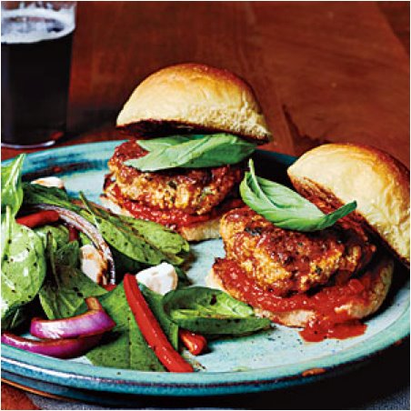
Italian Meatloaf Sliders

1 tablespoon olive oil, divided
3 garlic cloves, minced
3 shallots, finely diced
1/3 cup part-skim ricotta cheese
1/4 cup chopped fresh parsley
1/4 cup Panko (Japanese breadcrumbs), toasted
1/2 teaspoon freshly ground black pepper
1/4 teaspoon crushed red pepper
1/8 teaspoon salt
8 ounces lean ground pork
2 (4-ounce) links turkey Italian sausage, casings removed
1 large egg
1 1/2 cups lower-sodium marinara sauce
12 slider buns, toasted
12 basil leaves

1. Heat 1 teaspoon oil in a large skillet over medium heat; swirl to coat. Add garlic and shallots to pan; sauté 3 minutes or until shallots are softened, stirring frequently. Combine shallot mixture, ricotta, and next 8 ingredients (through egg) in a medium bowl. Shape mixture into 12 mini meatloaves. Press into each well of Brownie Pan & bake at 350 for 15-20 minutes.

2. Top bottom half of each bun with 1 1/2 tablespoons sauce, 1 meatloaf, 1 basil leaf, and top half of bun.

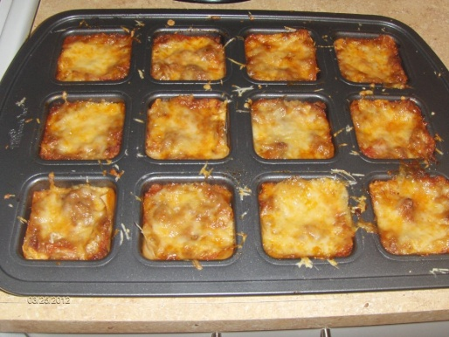
Mini Lasagnas (makes 2 trays!)

1 lb hamburger
1 15 oz container ricotta cheese
1 egg
1 box no-boil lasagna noodles
Italian seasoning
2 jars spaghetti sauce
Cheese - use a combination of Mozzarella and Cheddar

Brown your hamburger. Put a small spoonful of sauce in the bottom of each Brownie Pan well. Shake pan to spread sauce around. Break apart the lasagna noodles. Chances are, you will only get one perfect square out of each noodle, but don't throw away the broken pieces! You can still use them! Just piece them together to make a layer! Place a layer of broken noodles on top of the sauce. Then add a small amount of burger. Mix the egg, ricotta, and Italian seasoning. Place a dollop of mixture on top of burger. Top with another layer of noodle. Press down on the top layer of noodle. You need to have enough space to put another layer of sauce. The no-boil noodles require the moisture of the sauce so you don't want to skimp on it! Fill the well with sauce. Cover with foil and bake at 350 for 25-30 minutes, until the noodles are soft. Top with cheese and bake an additional 5 minutes to melt the cheese.

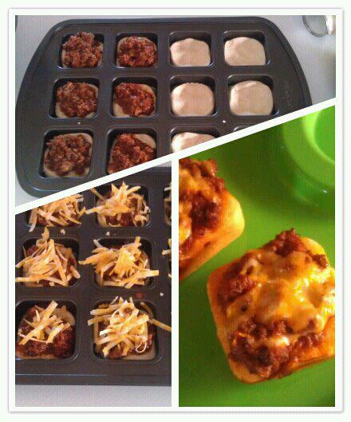
Sloppy Joe Cups

1 1/2 lbs ground beef
Minced onion
Salt & pepper to taste
1 cup ketchup
1/2 cup tomato juice
1 T chili powder
2 cans biscuits- use the ones that come in a 4 pack
Shredded cheese of choice

Brown burger with onion and salt and pepper. Add ketchup, tomato juice, and chili powder. Press one biscuit into the bottom of Brownie pan, add medium scoop of sloppy joe mixture, and top with a little cheese. Bake 325 for 15-17 minutes

Turkey Meatloaf Muffins topped w/Spinach & Garlic Mashed Potatoes

1 tsp olive oil | Chives, chopped | 1/2 sweet yellow onion, diced
3 (yellow, red, orange) small baby bell peppers, diced | 7 button mushrooms, chopped | 1 lb lean ground turkey
2 tbsp garlic and herb bread crumbs | Sea salt and freshly cracked pepper, to taste | 1 egg
3 tbsp parsley, chopped | 3 cloves of garlic, minced | 1-2 tbsp milk
Garlic mashed potatoes | Fresh spinach

Preheat the oven to 350 degrees. Spray the brownie pan lightly with olive oil. Heat the olive oil in a skillet over medium heat. Add the mushrooms, onions, and red pepper for 5-7 minutes or until softened; add the minced garlic and cook, stirring constantly for 1 minute. Combine the mushroom mixture with the ground turkey, bread crumbs, milk, egg, and parsley together in a bowl until well combined.
Scoop the meatloaf mixture evenly into the brownie pan, pushing down to flatten the meatloaf into the tray. Place in the oven and bake for 25-30 minutes or until the turkey is cooked through.
While the meatloaf is baking, make the garlic mashed potatoes Right before you take the meatloaf out of the oven, wash the spinach and place in a skillet over medium heat. Cook the spinach with a touch of water, making sure to season with sea salt and freshly cracked pepper, to taste, for 1-2 minutes.
Remove the turkey meatloaf muffins from tin, add wilted spinach on top of the meat then spoon mashed potatoes on top of the spinach then sprinkle the chives on top of the potatoes. Serve immediately. Enjoy.

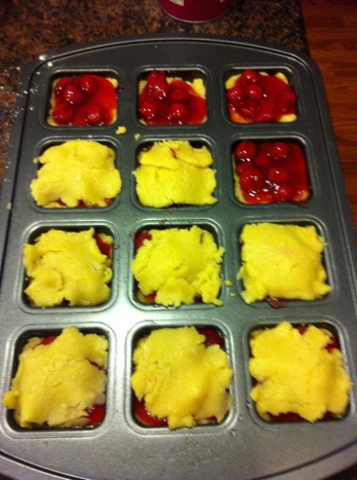
PIES & DESSERT BARS

Cherry Bars

1 c. margarine or butter
1 ½ c. sugar
3 eggs
2 ¾ c. flour
1 ½ tsp baking powder
½ tsp salt
21 ounce can of cherry pie filling (or fruit filling of choice), or equivalent of homemade filling

Preheat oven to 350 degrees. In a large bowl mix all ingredients except pie filling; mix until well blended. Spread Medium Scoop of batter into each well of the brownie pan. Scoop pie filling on top. Drop remaining batter on top of pie filling and spread. Bake for 15-20 minutes.

FYI - as they bake they will expand above the pan but they stay together while baking.

Individual Pretzel Cheesecakes

About 20 Bavarian Pretzels | 1/2 cup Butter (melted)
2 – 8 oz. packages of cream cheese | 3/4 cups white granulated sugar
1/2 cup milk | 2 eggs
1 cup Sour Cream | 1 T. vanilla extract
2T flour

Preheat the oven to 350 degrees. Grease brownie pan wells – this recipe will make 24 cheesecakes.
You can grind up the pretzels to a graham cracker crust consistency if you like. I chose to leave them a little chunky because I wanted to be able to really bit into the pretzels. Mix the pretzel mixture with the melted butter. Stir to coat evenly. Layer some of the pretzel mixture in the bottom of the greased muffin tins. You can also use paper muffin cups if you want to have them more like a cupcake or if you need to store them for a while. Set aside.
Next, you will be making the cheesecake filling. My favorite part!
In a mixer, blend together the cream cheese and sugar until smooth. Go ahead and add the remaining ingredients making sure they are all well blended until smooth. Pour into each brownie well on top of the pretzel crust. Time to pop them into the 350 degree oven for approximately 20 – 25 minutes. Allow to cool completely and then run a nylon knife around the edges to get the cheesecake out of the pan. Chill before serving. These are the perfect mini dessert. Creamy cheesecake with a pretzel crust. The pretzel crust is NOT crunchy like a regular pretzel. Because it is mixed with the butter and cooked, it comes out kind of nutty and chewy.

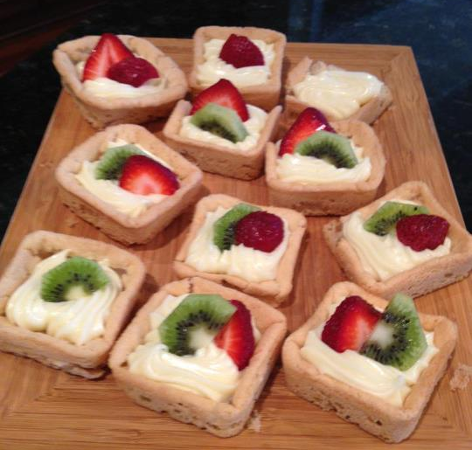
Kiwi Strawberry White Chocolate Margarita Tarts
1 premade roll of Sugar Cookie Dough (Pillsbury)
2 squares (1 oz each) white chocolate for baking
2 tablespoons milk
1 package (8 oz) cream cheese, softened
1/4 cup powdered sugar
3 Tablespoons Itty Bitty Bevs Margarita Mix
Kiwi and Strawberries for Garnish

1. Preheat oven to 350. Spray cups of Brownie Pan with non-stick cooking spray. Slice ¾ of the roll of Sugar Cookie Dough into equal slices and put one in each well of the Brownie Pan. Bake 12-14 minutes or until edges are set.

2. Remove pan to Stackable Cooling Rack. Cookies will make their own indentations as they cool. Cool in pan 10 minutes. Loosen edges and gently remove the brownies from pan. Cool completely.

3. Microwave white chocolate and milk, uncovered, on high for 1 minute; stir until smooth. Cool slightly. Combine cream cheese, Margarita Mix and powdered sugar; mix well. Gradually stir in white chocolate mixture until smooth.

4. Pipe mixture into cooled brownie cups using the Easy Accent Decorator. Arrange strawberry and kiwi slices on top
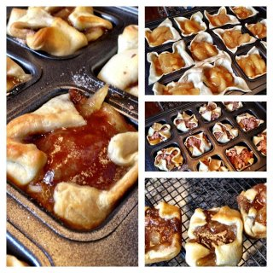

Mini Apple Pies

1 package of crescent roll creations
1 can of sugar free apple pie filling
5 Tbs of flour
2 Tbs of sugar
1/2 tsp cinnamon
2 tbs butter
Preheat oven to 350. Roll out dough and use the bakers roller

to flatten and enlarge dough. Use the pizza cutter to cut into squares. Place dough in the brownie pan; using Medium Scoop. Top with one scoop of apple pie filling.

In a separate bowl combine flour and sugar, then cut in butter until crumbly. Add to the top of each square.

Pull corners to the middle and add another dash of the crumble. (You might half the mixture or just go crazy and add a lot depending on how much topping you like)

Bake for 15 -17 minutes or until golden brown. Remove from pan immediately. Serve with ice cream or eat them COLD :) Either way is AMAZING!
SIDE ITEMS

Mini Mac and Cheese Pies
1 and 1/2 cups Ritz crackers, crushed (Use one whole sleeve crush using food processor)
2 cups white cheddar cheese, grated and divided
4 tablespoons unsalted butter, melted
4 and 1/2 cups cooked elbow macaroni (about 8 ounces uncooked)
One 5.2-ounce container of Boursin Garlic and Herb cheese
2 tablespoons unsalted butter, cold
2 large eggs
1/2 cup milk
1/4 cup sour cream
1/4 teaspoon salt
Pinch red pepper flakes
Parsley, for garnish, optional
1. Preheat the oven to 350 degrees. Generously spray 8 cups of your brownie pan with cooking spray.
2. In a large bowl, combine the crushed Ritz crackers, 1 cup of the shredded white cheddar cheese, and the melted butter, mixing well until the mixture holds together and resembles coarse sand. Divide the mixture among the 8 muffin cups and, using your fingers or the back of a spoon, firmly press the crust into the bottoms and up the sides of each well.
3. In another large bowl, combine the cooked (and still hot!) macaroni with 1/2 cup of the shredded white cheddar, the Boursin cheese, and the butter, mixing well. In a small bowl, combine the eggs, milk, sour cream, salt, and red pepper flakes, mixing well. Add the egg/milk mixture to the cooked macaroni, mixing until all the ingredients are melted and smooth.
4. Place about 2-3 tablespoons of the macaroni mixture into each muffin cup (you will probably have a little leftover macaroni. Save this and bake it separately, if desired. Top each muffin cup with the remaining white cheddar. Bake the mac and cheese pies until lightly golden on top, about 20-25 minutes. Let cool slightly before removing from the muffin pan, garnish with parsley, and serve immediately.
Sausage Herbed Stuffing Muffins

6 1/2 cups of white bread, cubed (about 1 loaf)
1/2 pound sausage browned
1 cup yellow onion, diced (about 1 medium yellow onion)
3 celery stalks, thinly sliced
1 leak, cleaned and thinly sliced
1 Tbsp rosemary herb seasoning
1/2 tablespoon salt* (See note below about salt)
1/2 teaspoon freshly ground pepper
1 cup low-sodium chicken stock
2 eggs, lightly beaten

1. Preheat the oven to 300 degrees F. Thoroughly butter the muffin tin and set aside.

2. In a single layer, place the bread cubes on two sheet pans and bake for 10 minutes, or until barely toasted. Remove and set aside.

3. In a large sauté pan, cook the sausage over medium-high heat, being sure to stir regularly, for about 7 minutes, or until slightly browned and crispy. Transfer to paper towels to drain. The sausage should release a few tablespoons of grease. This is good! We’ll use this to cook the vegetables. If for some reason your sausage is super lean, you might want to add a teaspoon of unsalted butter. Bring heat down to medium, and add the diced onion, sliced celery, sliced leek, salt and pepper, and cook until all is softened and translucent, about 10 minutes. Add the rosemary herb seasoning and cook just until fragrant.
4. Turn off the heat and add sausage, toasted bread crumbs and chicken broth to the vegetable mixture and toss. Do a taste test. Does it need a bit more salt? If you’re all good then add the slightly beaten eggs and mix once more.

5. Using a scoop, transfer mounds of the stuffing mixture to each well in the brownie pan. Be sure to tightly pack the stuffing in each of the cups. This will make sure the mixture adheres to itself and the muffins don’t fall apart.
6. Bake for 20-25 minutes, until top is browned. To remove, take a nylon knife and go around each of the stuffing muffins’ outer edge. Using your knife, gently lift it up out of the brownie pan. Serve warm.
Buffalo Chicken Cups –
Ingredients:
1 (8 ounce) package cream cheese, softened
1/2 cup Ranch dressing
1/2 cup Buffalo wing sauce (Frank's Red Hot is the brand I like)
1 cup shredded cheddar cheese, divided
1 1/2 cups cooked and shredded chicken
24 wonton wrappers
1/4 cup blue cheese crumbles
Directions:
1. Preheat oven to 375 degrees. You can spray brownie pan very lightly with kitchen spritzer.
2. In a medium bowl, combine softened cream cheese, Ranch dressing, wing sauce and 3/4 cheddar cheese (save remaining 1/4 cup for topping). You can soften the mixture slightly in the microwave if needed to make it come together. Stir in shredded chicken.
3. Start layering your cups. Begin with a wonton wrapper and press it into the bottom of each well. Spoon about a tablespoon of the chicken mixture. Top with another wonton wrapper and add another tablespoon of chicken mixture. Sprinkle with remaining cheddar cheese and a little blue cheese.
4. Bake for 18 minutes or until edges are brown. Check cups after 10 minutes into cooking and if edges are browned cover the cupcakes with foil for the remaining cooking time.
5. Remove from oven and let cool for 5 minutes. To remove, use a mini nylon spatula to loosen the edges then pop each cup out.

POTATO PUFFS
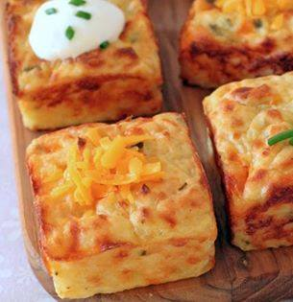
Ingredients
3 cups of mashed potatoes
2 eggs
1/3 cup sour cream (optional extra for serving)
1 heaping cup shredded sharp cheddar cheese
2 tablespoons grated Parmesan
2 tablespoons chopped chives or parsley
Salt and black pepper, to taste

Directions
- Preheat oven to 400 degrees F.
- Lightly grease with butter 8 - 9 of the wells of a nonstick muffin pan.
- In a medium mixing bowl whisk the eggs then mix in the sour cream.
- Stir in both cheeses and the chives.
- Add potatoes and mix well.
- Spoon them into the pan filling the cups to slightly below the top.
- Bake 25- 35 minutes until they pull away from the sides of the cup and are golden brown.
- Remove from oven and let them cool 5 minutes in pan. Serve with sour cream if desired.

