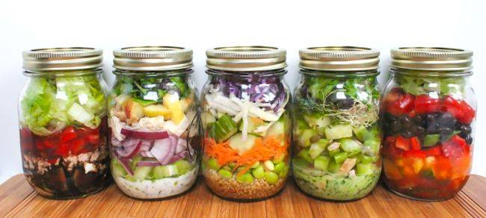

MEALS IN A JAR
RECIPES
BROUGHT TO YOU BY
YOUR INDEPENDENT PAMPERED CHEF CONSULTANT

Salad In A Jar Recipes
credit to: backtotheroots.com, organizeyourselfskinny.com, 4theloveoffood.com, theyummylife.com, 100daysofrealfood.com, whatsgabycooking.com, joyoushealth.com, sugarfreemom.com, thekitchn.com, foxeslovelemons.com, Michael Yokley

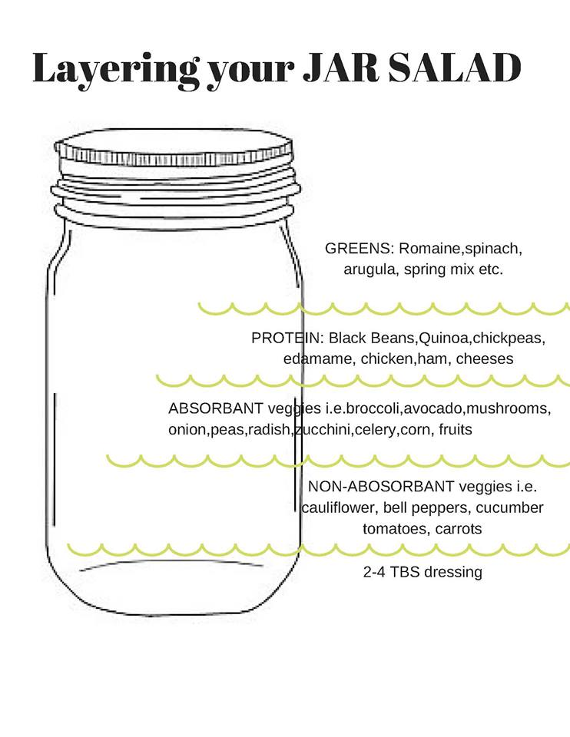

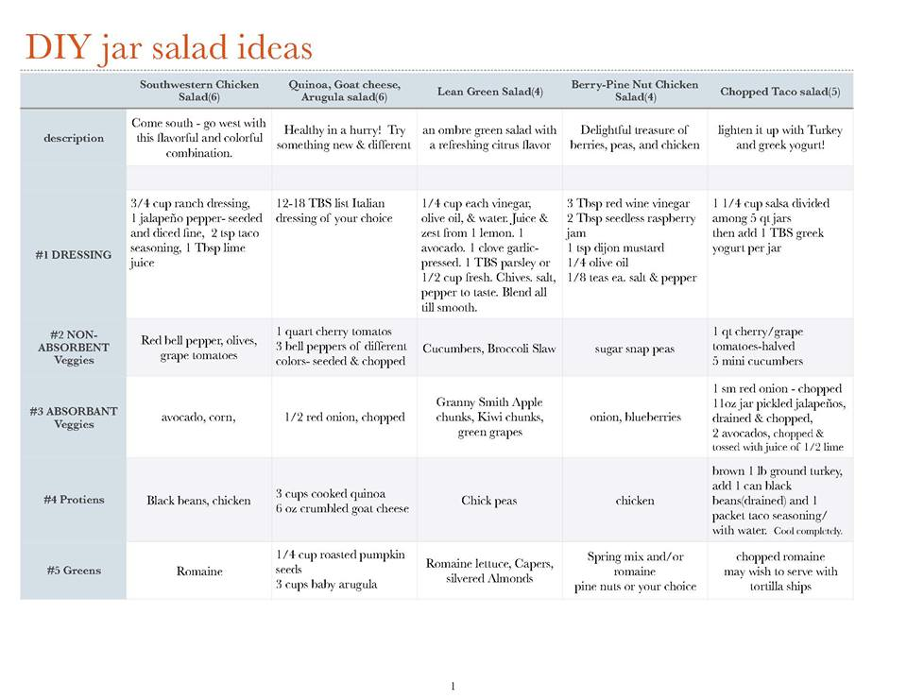

Antioxidant Salad
Start with white balsamic vinaigrette. Layer in mixed berries, sprouts, carrots, almonds, goat cheese*, flax seeds and mixed greens.

Mediterranean Salad
Start with balsamic vinaigrette. Add in artichokes, black olives, tomatoes white cannellini beans, cucumbers, Parmesan, pine nuts, oregano and mixed greens.

High Protein Salad
Start with the lemon-based dressing of your choice. Next throw in chickpeas, broccoli, cooked quinoa, corn, peas, currants or figs, pumpkin seeds, shredded Parmesan and spinach.

Detox Salad
Start with the lemon-based dressing of your choice. Layer in pineapple, blueberries, cooked quinoa, fennel, sprouts and kale. *I am going to skip the cannellini beans they recommend!

Greek Salad
Ingredients
5 quart size wide mouth mason jars
10 tablespoons Newmans Own Olive Oil and Vinegar Dressing
1 quart cherry tomatoes, halved
5 mini cucumbers, sliced
1 cup pitted Greek olives, sliced or chopped
¾ cup crumbled feta cheese
2 cups chopped or shredded rotisserie chicken
5 cups chopped romaine lettuce
Instructions
Divide and layer all ingredients into mason jars. Start with salad dressing, then tomatoes, cucumbers, olives, cheese, chicken, and end with lettuce. Put mason jar top on and store in refrigerator.
When ready to eat pour into a bowl and serve.

Chopped Black Bean and Corn
Ingredients
5 wide mouth quart size mason jar salads
1 ¼ cup salsa
1 6 ounce container plain Greek yogurt
1 quart cherry tomatoes, halved
1 red onion, chopped
2 cans black beans, drained and rinsed
1 12 ounce package frozen corn, thawed
2 avocados, peeled and chopped
5 ounce block pepper jack cheese, cut into small cubes
4-5 cups chopped romaine lettuce
¼ cup or more chopped cilantro (optional)
Instructions
In each of the mason jars pour ¼ cup of salsa. Then divide the Greek yogurt evenly among the jars. This will equal about 1 ½ tablespoons of Greek yogurt per jar. Next divide and layer the rest of the ingredients evenly between the 5 mason jars starting with tomatoes then following with onions, black beans, corn, avocado, cheese, and ending with romaine and cilantro. When ready to eat pour into a bowl, mix together, and enjoy!

Italian
Ingredients
5 qt size Wide Mouth Mason Jars
10 tablespoons balsamic vinegar dressing (I use Newmans own brand)
1 quart grape tomatoes
10 ounces fresh mozzarella
2 cups dry whole grain pasta, cooked
10 cups baby spinach
5 quart size mason jar salads
Instructions
Divide ingredients evenly in 5 mason jars starting with dressing, then tomatoes, mozzarella, pasta, and ending with spinach. Place lid on jar and close tight.
Shake jar to coat dressing and pour into bowl to eat.

Artichoke and Tortellini
Ingredients
5 quart size wide mouth mason jars
10 tablespoons Italian dressing (I used Newmans Own Family Recipe Italian)
1 quart cherry tomatoes, halved
1 red onion, chopped
2 cans quartered artichoke hearts, cut in half
4 ounces dried cheese filled tortellini; cooked according to package directions (I bought the 8 ounce bag of Barilla brand cheese filled tortellini and only used half)
5 ounces goat cheese
5 cups bagged spinach/arugula blend salad
Instructions
Layer each mason jar with the ingredients starting with dressing then adding tomatoes, onion, artichokes, tortellini, goat cheese, and finishing with arugula/spinach blend.
When ready to eat give the salad a shake and pour into a bowl.

Chopped Broccoli, Ham, and Swiss
Ingredients
5 wide mouth quart size mason jars
15 tablespoons yogurt coleslaw dressing
3 large red bell peppers, chopped
3 broccoli crowns, chopped small
½ pound thick sliced organic deli ham, chopped
6 ounces dry spiral whole grain pasta, cooked and cooled
5 ounces block Swiss cheese, chopped
5 tablespoons pumpkin seeds
5 cups spinach, arugula, radicchio salad blend
Instructions
Pour 3 tablespoons of salad dressing into each of the mason jars. Then layer ingredients into the jar starting with peppers then following with broccoli, ham, pasta, cheese, pumpkin seeds, and finishing with salad blend.
To eat pour salad into a bowl and mix all ingredients together until evenly coated with salad dressing

Burrito Bowl Mason Jar Salads
Yield: 5 salads
Serving Size: 1 pint-sized mason jar salad
Ingredients
Cooked quinoa. To the quinoa add: Juice and zest of one lime, or 2 tablespoons lime juice,
1/4 cup chopped fresh cilantro
Cooked chicken, chopped or shredded
Cooked Bacon, chopped
Sweet potato, cubed and roasted
3 cups chopped lettuce
5 tablespoons plain Greek yogurt
3/4 cup shredded cheese
1/2 cup chopped fresh cilantro
To assemble the salads:
Add 1 tablespoon of plain Greek yogurt to the bottom of each pint-sized wide mouth mason jar.
Top with about 2 tablespoons of sweet potato cubes.
3-4 tablespoons of the cilantro lime quinoa.
Cheese
Bacon
Chicken (To make this vegetarian, substitute 1 can of rinsed beans for the chicken and bacon and add a layer of beans here.)
Fill the remaining space in the mason jar with lettuce, and sprinkle some additional chopped cilantro on top before screwing on the lid.

Caprese Salad in a Jar
Dressing (recipe below)
1/2 cup cherry tomatoes, halved
fresh mozzarella, cubed
2 cups of romaine
1/2 cup green basil , chopped
For the dressing:
2 tbsp. olive oil
1/2 tablespoon balsamic vinegar
a drop of honey, salt, cracked black pepper
Black Bean and Corn
Ingredients
5 wide mouth quart size mason jar salads
1 ¼ cup salsa
1 6 ounce container plain Greek yogurt
1 quart cherry tomatoes, halved
1 red onion, chopped
2 cans black beans, drained and rinsed
1 12 ounce package frozen corn, thawed
2 avocados, peeled and chopped
5 ounce block pepper jack cheese, cut into small cubes
4-5 cups chopped romaine lettuce
¼ cup or more chopped cilantro (optional)
Instructions
In each of the mason jars pour ¼ cup of salsa. Then divide the Greek yogurt evenly among the jars. This will equal about 1 ½ tablespoons of Greek yogurt per jar. Next divide and layer the rest of the ingredients evenly between the 5 mason jars starting with tomatoes then following with onions, black beans, corn, avocado, cheese, and ending with romaine and cilantro. When ready to eat pour into a bowl, mix together, and enjoy!

Black and Bleu Salad
Ingredients
Dressing
Whisk together:
1/3 cup olive oil
3 tablespoons red wine vinegar
2 tablespoons lemon juice
1 clove garlic, minced
1/2 teaspoon salt
1/8 teaspoon ground black pepper
1 teaspoon Worcestershire sauce
(or use bottled Italian Dressing)

1/4 cup crumbled blue cheese
beef sirloin steak - grilled and sliced (great use for leftover steak)
Green bell pepper, chopped
Carrot, chopped
red onion, sliced
Pimento-stuffed green olives, chopped
Cherry Tomatoes, halved
Romaine Lettuce, cleaned, dried, and chopped
Layer in above order

Strawberry Spinach Salad with Strawberry-Lime Vinaigrette
To make this salad, in the jar, put items in this order:
Strawberry-Lime Vinaigrette (see recipe below—I use about two tablespoons of dressing per pint-sized jar)
Cooked Quinoa
Sliced Strawberries
Sunflower Seeds
Sliced Green Onions
Crumbled Feta
Baby Spinach
Depending on how juicy your strawberries are, you might want to put them down lower in the jar (before the quinoa) to keep them even further away from the spinach.

Strawberry-Lime Vinaigrette
2 tablespoons extra virgin olive oil
2 teaspoons strawberry preserves
1 tablespoons fresh lime juice
1 teaspoon mustard
1 tablespoon white wine vinegar
Salt and pepper, to taste
Combine all ingredients in a jar with a tight-fitting lid. Close and shake until emulsified. Makes about four tablespoons of dressing (enough for two-pint-sized jars).

Mexican Chickpea Salad with Chile-Lime Dressing
To make this salad, in the jar, put items in this order:
Chile-Lime Dressing (see recipe below—I use about two tablespoons of dressing per pint-sized jar)
Cooked Brown Rice
Cooked Chickpeas
Salsa
Red Onions
Halved Grape Tomatoes
Chopped Cilantro
Chopped Romaine
Because of the tomatoes and salsa, this salad is a bit “wetter” than others and care should be taken not to tip it or turn it to avoid the romaine getting soggy.
Chile-Lime Dressing
2 tablespoons extra virgin olive oil
2 tablespoons fresh lime juice
1 teaspoon dried ground cumin
Pinch red pepper flakes
Salt and pepper, to taste
Combine all ingredients in a jar with a tight-fitting lid. Close and shake until emulsified. Makes about four tablespoons of dressing (enough for two-pint-sized jars).
Sunshine Salad with Orange Marmalade Vinaigrette
To make this salad, in the jar, put items in this order:

Citrus Orange
Orange Marmalade Vinaigrette
(see dressing recipe below - use about two tablespoons of dressing per pint-sized jar)
Cooked Quinoa
Clementine Wedges
Sliced Red Onions
Sprouted Lentils
Pine Nuts
Chopped Romaine
Baby Spinach
I use fresh Clementine wedges but you can just as easily use canned mandarin slices—just make sure to drain them well before adding to the jar.

Orange-Marmalade Vinaigrette
2 teaspoons orange marmalade
2 tablespoon apple cider vinegar
2 teaspoons extra virgin olive oil
Pinch red pepper flakes
Salt and pepper, to taste
Combine all ingredients in a jar with a tight-fitting lid. Close and shake until emulsified.

Tofu Salad
To make this salad, in the jar, put items in this order:
Sesame-Lemon Dressing (see recipe below—I use about two tablespoons of dressing per pint-sized jar)
Drained, Pressed and Cubed Extra Firm Tofu
Sliced Red Bell Pepper
Chopped Cucumbers
Sprouted Lentils
Sunflower Seeds
Chopped Parsley
Chopped Romaine
Small cubes of firm tofu act like little protein-packed sponges soaking up all the dressing goodness. Not into tofu? No problem. Shelled edamame will work great

Sesame-Lemon Dressing
1 tablespoon tahini
1 tablespoon lemon juice
Pinch of red pepper flakes
1 teaspoon sesame oil
1 tablespoon rice wine vinegar
1 teaspoon honey
1/4 teaspoon salt
1/4 teaspoon black pepper
1/4 teaspoon oregano
1 clove garlic, minced

Asian Noodle Salad Jars
Dressing (recipe below)
Cooked soba noodles
Red bell pepper, thinly sliced
Shelled edamame, cooked
Carrots, peeled and shredded
Green onions, thinly sliced
Crunchy rice noodles

For The Spicy Peanut Dressing:
2 tablespoons peanut butter
4 teaspoons sambal oelek
4 teaspoons rice vinegar
4 teaspoons soy sauce
1/4 cup extra virgin olive oil
1 tablespoon black sesame seeds

Divide Spicy Peanut Dressing equally among 4 pint-sized mason jars. Divide soba noodles over dressing. Layer remaining ingredients, ending with rice noodles. Top with lids and refrigerate up to 5 days. To serve, pour onto plate or bowl, stir and enjoy.

Southwest Ranch Chicken
Ingredients
5 wide mouth mason jars
10 tablespoons Southwest Ranch Yogurt Dressing
Grape tomatoes, sliced in half
Bell peppers (any color), chopped
Red onion, chopped
Black beans, drained
Chicken, cooked and shredded
Avocado, skinned and chopped
fresh lime juice
Cheese, shredded
Lettuce Mix: Romaine and cilantro
Tortilla chips, chopped
Instructions
Divide ingredients evenly among the mason jars. Start with the dressing and then add the tomatoes, bell peppers, onions, avocado (squirt with lime juice first), black beans, chicken, cheese, and end with the romaine. Put the lid on and store in the refrigerator for up to 5 days.
Serve with crushed tortillas.

Southwest Grilled Chicken Salad with Spicy Cilantro Lime Dressing
Created by: Michael Yokley, Advanced Director with The Pampered Chef
Dressing, recipe below
Grilled or Cooked Chicken, cubed or shredded
Mexicorn (Also called southwest style corn – sometimes available frozen)
Black Beans
Cherry/grape tomatoes , halved
Red onion , chopped
Monterey Jack cheese , shredded
Tortilla strips , chopped
Romaine lettuce, dried and chopped
Cilantro, dried and chopped

Dressing:
1 large jalapeno seeded and deveined
2 cups loosely packed cilantro
3 cloves of garlic, pressed
1 tbsp. Three Onion Rub
1 tbsp. Garlic Herb Rub
Juice from 1 ½-2 limes
1 ½ cup non-fat/low fat Greek yogurt
1 avocado
Directions:
Add jalapeno, cilantro, and garlic pressed with Garlic Press to the Manual Food Processor (MFP). Pulse until fine.
Using Citrus Press, press lime juice into MFP.
Using Measuring Spoon Set, add both rubs to MFP. Pulse to combine.
Remove avocado and dice using avocado peeler and place in MFP. Pulse until smooth.
Using Measure-All Cup, measure Greek yogurt and add to MFP. Pulse to combine.

7 Layer Salad
Dressing (see recipe below)
Bacon, cooked and chopped
Yellow (or red) onion, diced
Red bell pepper, diced
Frozen peas, partially thawed
Eggs, hard boiled and peeled
Lettuce, washed and chopped (Use romaine and/or butter lettuce)
Dressing:
1/2 cup mayo
1/2 cup sour cream
1 tbsp sugar
1/2 tsp black pepper
Whisk above ingredients together

Add a couple spoonfuls of dressing in the bottom of the jar, layer in order above

Cheeseburger Salad
Lean ground beef, cooked
Ketchup
Yellow mustard
Cherry tomatoes, halved
Dill Pickle Spears, chopped
Red onion
Shredded cheddar cheese
Romaine lettuce leaves, chopped
Thousand Island Dressing or Special Sauce
Layer contents into mason jar starting with dressing then tomatoes, pickles, onions, cheese, cooled beef mixture and finally lettuce.
Serve immediately (or soon after) or store in refrigerator up to 4 days.

Southwestern Barbecue Grilled Veggie
Salsa - your favorite recipe/variety (bottom layer)
Avocado - cubed (the salsa acidity will keep it fresh)
Cilantro leaves - chopped
Grilled (or fresh) red onion - chopped
Grilled yellow, orange, and red pepper, (or fresh) - chopped
Grilled corn (cut fresh from cob), (or canned)
Black beans - rinsed and drained
Cooked brown rice seasoned with a squeeze of lime
Romaine lettuce - chopped (top layer)
Layer the ingredients as listed from bottom to top in a jar. Serve immediately or store in a refrigerator for up to 5 days.

Taco Salad
Salsa
Ground turkey or beef, cooked with taco seasoning
1/3 cup sour cream
shredded cheese
guacamole
Lettuce, shredded

Layer, salsa, ground turkey mixture, sour cream, shredded cheese, guacamole, shredded lettuce.

Buffalo Chicken Salad
Blue cheese yogurt dressing
Hot sauce (preferably Frank's hot sauce)
Cherry tomatoes, halved
Red onion, chopped
Carrots, chopped
Celery stalks, chopped
Shredded chicken
Chopped romaine lettuce
Instructions
Divide ingredients among mason jars starting with dressing then following with hot sauce, tomatoes, onion, carrots, celery, chicken, and ending with romaine.
Chopped Cobb
Yogurt blue cheese dressing
Cherry tomatoes, halved
Cucumbers, sliced
Red onion, chopped
Hard-boiled eggs, chopped or sliced
Avocados, chopped
Bacon, cooked and crumbled
Turkey, cut into pieces
Sliced ham, cut into pieces
Chopped romaine lettuce Layer above ingredients in order starting with dressing

Shrimp & Feta Cobb Salad
Dressing of choice
Chopped avocado
Grape tomatoes sliced in half
Red onion, chopped
Cucumber, chopped
Romaine lettuce and baby spinach, chopped
Feta, crumbled
Shrimp, cooked
Egg, hard boiled and chopped
Bacon, chopped Layer all items in order starting with the dressing

Zucchini (Zoodles)Pasta Salad with Avocado Dressing
Dressing (recipe below)
Celery, sliced
Red bell pepper, chopped
Shelled edamame
Feta cheese
Cherry tomatoes, halved
Kalamata olives, chopped
Spiraled zucchini (Zoodles)

Avocado Spinach Dressing
1/2 cup fresh packed spinach
1/2 ripe avocado
Juice of 1 lemon
2 tablespoons extra virgin olive oil
2 tablespoons Greek yogurt, plain, 2%
1/2 teaspoon salt
1/4 teaspoon pepper
Layer:
Dressing into the bottom, then rest of ingredients in above order
Cover and refrigerate. Last up to 5 days.
Once ready to eat, shake the jar vigorously then pour onto a plate. Toss with fork if needed to mix dressing.

Pasta Salad
2 cups Greek vinaigrette
Cooked Tortellini
Pepperoni, Sliced
Cherry tomatoes, halved
Red onion, finely chopped
Artichoke hearts, drained and coarsely chopped
Roasted sweet red peppers, drained and chopped
Black Olives, drained
Basil, chopped
Parmesan cheese, Grated
Layer Above Ingredients in Mason Jar

How To Make Instant Noodle Cups in a Mason Jar
Ingredients for each noodle cup
1 to 3 teaspoons flavor base — soup stock paste (like Better Than Bouillon), miso paste, curry paste
1 to 3 teaspoons flavoring extras, optional — chili-garlic sauce, soy sauce or tamari, coconut milk, sesame oil, Sriracha or other hot sauce
1/4 to 1/2 cup filler ingredients — frozen corn, frozen carrots, frozen peas, diced tofu, leftover cooked meat, dried or thinly sliced mushrooms, thinly sliced spinach or other hearty greens, kimchi, soft-boiled or hard-boiled egg
3/4 to 1 cup noodles — cooked udon, cooked yakisoba or ramen, cooked soba noodles, cooked spaghetti or fettuccine, cooked rice noodles, cooked shirataki noodles, dry vermicelli or maifun noodles
1/4 to 1/2 cup fresh ingredients — fresh herbs, sliced green onions, bean sprouts, sliced lime or lemon
Place flavor base and flavor extras in the bottom of the cup: If it's a paste, like soup stock or miso paste, spread it around a little so it dissolves more easily once you add the hot water. Also add any flavoring extras.
Top with filler ingredients: Scatter your filler ingredients over the top of the paste. It's OK if they get mixed in with the flavor base and extras.
Add the noodles: Pack the noodles down so they're fairly compact. It's fine if they stick together — they will un-stick once you add the water.
Finish with the fresh ingredients
Seal and refrigerate: Place the lid on the container and refrigerate for up to a week.
Instructions for Cooking the Noodle Cups
Top with hot water: When you're ready to eat, unscrew the lid and pour enough boiling water over the top of the noodles to cover.
Cover and steep: Place the lid back over the container. Let the soup steep for 2 to 3 minutes. The ingredients should be warmed through, but the soup is still nicely hot.
Stir thoroughly (Alternatively, you can pour the soup out into a bowl and mix everything there.)

Breakfast Ideas

Easy, no-cook oatmeal with make-ahead convenience; packed with nutrition to get your day off to a healthy start. Make it in individual mason jars for a perfect serving size and an easy grab-and-go breakfast.

Mango Almond Refrigerator Oatmeal

Ingredients
1/4 cup uncooked old fashioned rolled oats
1/3 cup skim milk
1/4 cup low-fat Greek yogurt
1-1/2 teaspoons dried chia seeds
1/8 teaspoon almond extract
1 teaspoon honey, optional (or substitute any preferred sweetener)
1/4 cup diced mango (approx. half of a small mango)

Directions
In a half pint jar or container, add oats, milk, yogurt, chia seeds, almond extract and honey. Put lid on jar and shake until well combined. Add mangoes and stir with fork until mixed throughout. Return lid to jar and refrigerate overnight or up to 2 days. Eat chilled.
Nutritional Info: 207 calories, 4g fat, 47g carbs, 7g fiber, 12g protein; Weight Watchers PtsPlus: 7

Blueberry Maple Refrigerator Oatmeal
Ingredients
1/4 cup uncooked old fashioned rolled oats
1/3 cup skim milk
1/4 cup low-fat Greek yogurt
1-1/2 teaspoons dried chia seeds
2 teaspoons maple syrup (more or less to taste)
1/4 cup blueberries (or enough to fill jar)

Directions
In a half pint (1 cup) jar, add oats, milk, yogurt, chia seeds, and maple syrup. Put lid on jar and shake until well combined. Remove lid, add blueberries and stir until mixed throughout. Return lid to jar and refrigerate overnight or up to 2 days. Eat chilled.
Nutritional Info: 215 calories, 4g fat, 48g carbs, 8g fiber, 12g protein; Weight Watchers PtsPlus: 7

Apple Cinnamon Refrigerator Oatmeal
Ingredients
1/4 cup uncooked old fashioned rolled oats
1/3 cup skim milk
1/4 cup low-fat Greek yogurt
1-1/2 teaspoons dried chia seeds
1/2 teaspoon cinnamon
1 teaspoon honey, optional (or substitute any preferred sweetener)
1/4 cup unsweetened applesauce, or enough to fill jar

Directions
In a half pint (1 cup) jar, add oats, milk, yogurt, chia seeds, cinnamon and honey. Put lid on jar and shake until well combined. Remove lid, add applesauce and stir until mixed throughout. Return lid to jar and refrigerate overnight or up to 2 days. Eat chilled.
Nutritional Info: 210 calories, 4g fat, 48g carbs, 8g fiber, 11g protein; Weight Watchers PtsPlus: 7

Banana Cocoa Refrigerator Oatmeal
Ingredients
1/4 cup uncooked old fashioned rolled oats
1/3 cup skim milk
1/4 cup low-fat Greek yogurt
1-1/2 teaspoons dried chia seeds
1 tablespoon cocoa powder
1 teaspoon honey, optional (or substitute any preferred sweetener)
1/4 cup diced ripe banana, or enough to fill jar (approx. half of a small banana)

Directions
In a half pint (1 cup) jar, add oats, milk, yogurt, chia seeds, cocoa powder and honey. Put lid on jar and shake until well combined. Remove lid, add bananas and stir until mixed throughout. Return lid to jar and refrigerate overnight or up to 2 days. Eat chilled.
Nutritional Info: 245 calories, 5g fat, 56g carbs, 10g fiber, 13g protein; Weight Watchers PtsPlus: 8

Banana Peanut Butter Refrigerator Oatmeal
Ingredients
1/4 cup uncooked old fashioned rolled oats
1/3 cup skim milk
1/4 cup low-fat Greek yogurt
1-1/2 teaspoons dried chia seeds
1 tablespoon peanut butter (may substitute PB2 powdered peanut butter)
1 teaspoon honey, optional (or substitute any preferred sweetener)
1/4 cup diced ripe banana, or enough to fill jar (approx. half of a small banana)

Directions
In a half pint (1 cup) jar, add oats, milk, yogurt, chia seeds, peanut butter (or PB2), and honey. Put lid on jar and shake until well combined. Remove lid, add bananas and stir until mixed throughout. Return lid to jar and refrigerate overnight or up to 2 days. Eat chilled.
Nutritional Info (using PB2 and no honey or sweetener): 264 calories, 5g fat, 55g carbs, 8g fiber, 15g protein; Weight Watchers PtsPlus: 8

Raspberry Vanilla Refrigerator Oatmeal
Ingredients
1/4 cup uncooked old fashioned rolled oats
1/3 cup skim milk
1/4 cup low-fat Greek yogurt
1-1/2 teaspoons dried chia seeds
1/4 teaspoon vanilla extract
1 tablespoon raspberry jam, preserves, or spread
1/4 to 1/3 cup raspberries (cut each berry in half), or enough to fill jar

Directions
In a half pint (1 cup) jar, add oats, milk, yogurt, chia seeds, vanilla, and raspberry jam. Put lid on jar and shake until well combined. Remove lid, add raspberries and stir until mixed throughout. Return lid to jar and refrigerate overnight or as long as 2-3 days. Eat chilled.
Nutritional Info: 230 calories, 4g fat, 51g carbs, 8g fiber, 11g protein; Weight Watchers PtsPlus: 7

Salted Turtle Refrigerator Oatmeal
Ingredients
½ cup unsweetened almond milk
1 medjool date, pitted and chopped
¼ teaspoon pure vanilla extract
½ tablespoon unsweetened cocoa powder
½ cup rolled oats
1-2 teaspoons pure maple syrup
2 teaspoons chopped pecans
sprinkle of sea salt
Winning Game Day Recipes
Instructions
In a pint size mason jar stir together almond milk, date, vanilla, and unsweetened cocoa powder until all combined.
Stir in rolled oats.
Place lid on and refrigerate for 8 hours or overnight.
Stir in a little extra almond milk to loosen oats up and to get the consistency you like.
Stir in maple syrup. Start with 1 teaspoon then give it a taste. If you need more sweetness then add in the rest.
Sprinkle with pecans and salt. Enjoy.
Nutrition Information
Serving size: 1 recipe Calories: 313 Fat: 6 Carbohydrates: 57 WW Points +: 8 Fiber: 8Protein: 8

Breakfast Parfait Refrigerator Oatmeal
Ingredients
MAKES 1
6oz Greek yogurt
1/3 cup certified gluten-free old fashioned oats, uncooked
1 teaspoon chia seeds (optional)
2 Tablespoons milk (almond, cow, soy, etc.)
1 cup frozen mixed fruit and berries
Directions
In a bowl combine yogurt, oats, chia seeds, and milk. Stir to combine then layer half in a wide-mouth mason jar or container. Add half the fruit and berries then layer in remaining yogurt mixture and berries. Refrigerate overnight, and up to 3 days.

Granola Breakfast
Instructions for 1 serving.
Grab your favorite glass jar and build your granola breakfast in layers.
Layer bottom with dark berries. About 1/3 cup frozen raspberries
Spoon yogurt. 1/4-1/2 cup
Add your favorite granola, 1/4-1/2 cup.
Half chopped banana
Sprinkle 1 tbsp sprouted chia seeds
Optional: Mix in 2 tbsp of your favorite protein powder into the yogurt.
Make these the night before and store in your fridge.

