ROCKCROK™ RECIPE BOOKLET
A COMPILATION FROM MANY TALENTED PAMPERED CHEF CONSULTANTS

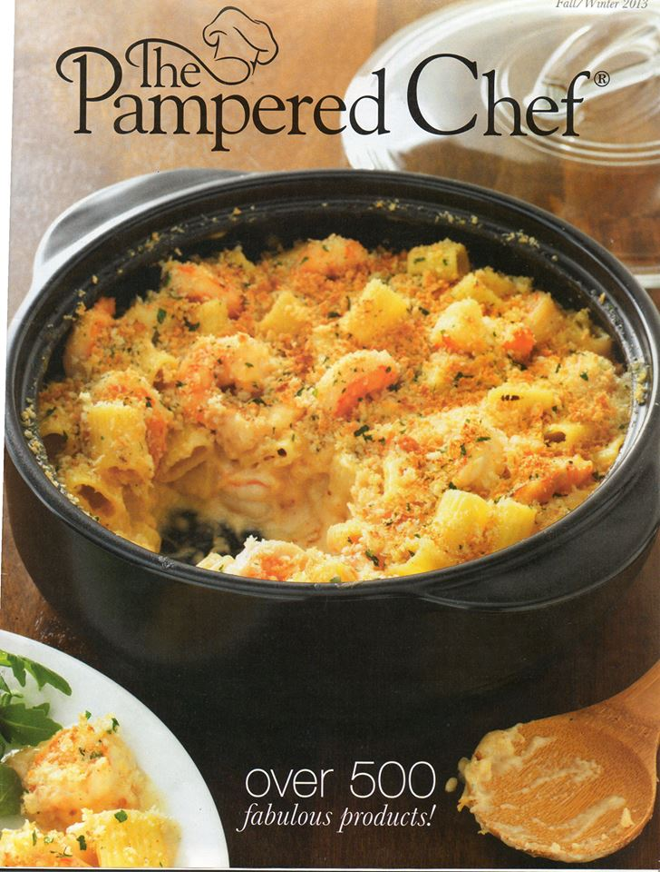

Presented to you by Your Pampered Chef Consultant
Marci Loehner
513-293-0617
www.pamperedchef.com/pws/marciloehner
Marci@MyHeavenlyRecipes.com

Contents

Contents 2
Upside-Down Cherry-S’more Cheesecake 3
Creamy One Pot Pasta 4
Mushroom and Spinach Risotto 4
Annelie’s Penne with Italian Sausage and Zucchini 6
Quick Pineapple Upside Down Cake 7
Angies Rockin Pot Pie 8
Gluten & Dairy Free Chicken Pot Pie, Dumpling Style 9
Chicken & Gravy Recipe 10
RockCrok™ Cashew Chicken 11
Beef Mexican Casserole 12
RockCrok™ Omelet 13
Homemade Hamburger Helper - Bernadette Story Howarth 14
RockCrok™ Chicken Pasta! 16
CHERRY VANILLA CAKE 17
Veggie Taco Base 18
Easy Chicken Pot Pie 19
Chicken Tortilla Casserole 20
Cheesy Shells & Italian Sausage 22
Family-Size Cheeseburger & Fries 23
Zesty Ravioli - RockCrok™ 26
Italian Pot Pie
Recipe by The Pampered Chef ® 27

Upside-Down Cherry-S’more Cheesecake
This recipe is a mixture of the Upside-Down Cherry Cheesecake and the new S'more Cake


Recipe and steps edited by Jenny Gray

Ingredients
Cake
9 oz. white cake mix
1 cup of sour cream
1 egg

Cheesecake filling
4 oz. softened cream cheese
3 Tbsp. powdered sugar
¼ tsp. vanilla

Directions
For Cake
Mix cake mix, sour cream and egg in Classic Batter Bowl using Stainless Whisk, pour into RockCrok™ and spread evenly on bottom using the Mix N’ Scraper.

For cheesecake filling
Mix cheesecake ingredients until smooth with Stainless Whisk, then drop evenly over top of cake with Small Scoop. Press a strawberry into each cheesecake dollop as well as in between dollops.

Microwave cake for 6 minutes
~ ~ ~ ~ ~ ~ ~ ~ ~ ~ ~ ~ ~ ~ ~ ~

Creamy One Pot Pasta
Recipe by The Pampered Chef®
Adapted for the RockCrok™ by Cindy Lazor
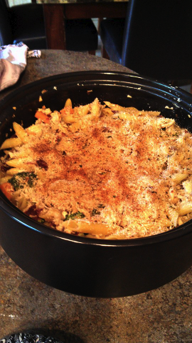

Ingredients
4 large garlic cloves, peeled
1 jar (7 oz) sun-dried tomatoes in oil, undrained
3 cans (14.5 oz each) chicken broth – 5 ¼ cups)
1 lb uncooked mezze penne pasta
1 head broccoli (2 cups small florets)
2 medium carrots, peeled (can use short-cut carrots)
4 oz reduced-fat cream cheese
¼ tsp. salt
½ tsp. coarsely ground black pepper
Small Block of fresh Parmesan cheese
¼ cup Panko bread crumbs (optional)

Directions
- Preheat oven broiler. Peel garlic using Garlic Peeler. Slice using Garlic Slicer.
- Heat RockCrok™ Dutch Oven over medium high heat. Add 1 Tbsp. of oil from sun-dried tomatoes into RockCrok™. Add sliced garlic and cook over medium heat 2-3 minutes or until garlic is golden brown, stirring occasionally. Add broth. Add pasta. Turn off heat and remove from heat.
- Add lid to RockCrok™ and place in the microwave for 14 minutes, stirring half-way through.
- Meanwhile, cut broccoli into small florets. Slice carrots using the Spiral and Slice. Drain sun-dried tomatoes; pat dry with a paper towel. Cut into thin strips using Professional Shears.
- Cut cream cheese into cubes. Add vegetables, cream cheese, salt and pepper to RockCrok™. Stir until cream cheese is melted and fully incorporated. Cover and cook an additional 2-4 minutes or until vegetables are tender.
- Grate Parmesan cheese with Microplane Adjustable Grater to measure about ¼ cup. Combine with Panko crumbs and sprinkle on top of pasta mixture. Place under the broiler for 30 seconds – 1 minute until topping is golden brown.
- Serve immediately and enjoy!
Variation: Place 2 boneless skinless chicken breasts halves in Round Covered Baker or Deep Covered Baker and cook in microwave 8 minutes or until cooked! Mix into the above recipe before topping with the parmesan/Panko crumb mixture and broil as directed.
~ ~ ~ ~ ~ ~ ~ ~ ~ ~ ~ ~ ~ ~ ~ ~

Mushroom and Spinach Risotto
Presented by CK Hall
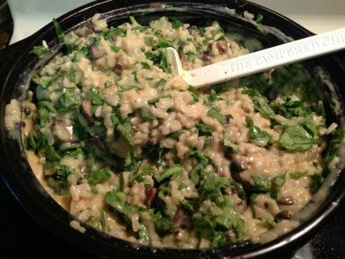

Ingredients
1 Tbsp. butter
1 pint/package mushrooms (Small Crimini or button), quartered or wedged with Veggie Wedger
1/2 onion, processed small with Manual Food Processor
2 Tbsp. olive oil
2 cloves pressed garlic
1-1/2 cups Arborio rice, uncooked
1 cup dry white wine (Sauvignon Blanc is good)
32 oz of chicken or vegetable stock
5 oz of Brie or Camembert Cheese (5 oz or more … CK prefers Camembert)
1/2 bag of baby spinach (washed)(add as much spinach as you would like)
1 Tbsp. lemon juice
Salt and pepper to taste

Directions
- Preheat RockCrok™ (RC) on stovetop on medium high heat for approximately 1-2 minutes. Add 1 Tbsp. butter and melt.
- Using Bamboo Spoon or Mix 'N Scraper, sauté mushrooms and onion, moving constantly until juices are almost gone, mushrooms browned, onion soft.
- Remove RC from heat and remove veggies to separate 3 cup Prep Bowl.
- Return RC to stovetop, add 2 Tbsp. olive oil, pressed garlic using Garlic Press and rice to pan, cook 2 minutes, stirring rice.
- Add wine and cook 2-3 minutes until wine is reduced by half, stirring occasionally.
- Remove pan from heat and add stock, stir, and microwave on high for 15-17 minutes or until most of liquid is absorbed and rice is tender.
- Meanwhile, cut rind from cheese and cut into cubes (discard rind). Juice lemon into Mini Measure Cup using Citrus Press.
- Remove pan from microwave, stir rice, add cheese, lemon juice, salt and pepper.
- Incorporate sauteed veggies and stir in spinach until wilted.
- Place RC on Round Up From The Heart Trivet to serve.
~ ~ ~ ~ ~ ~ ~ ~ ~ ~ ~ ~ ~ ~ ~ ~

Annelie’s Penne with Italian Sausage and Zucchini
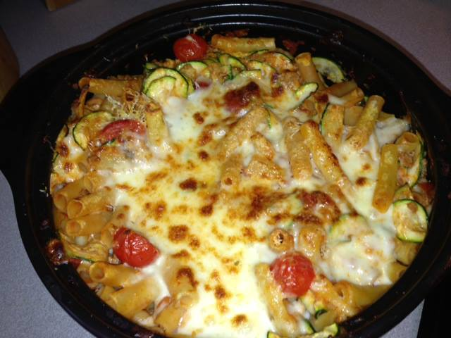
Recipe and steps edited by Penney Parkes

Ingredients
1 box of penne pasta
3/4 lb ground Italian sausage or turkey sausage
2 small zucchini, sliced with Spiral & Slice
1 cup cherry tomatoes, sliced in half
2 cloves garlic
1 jar of marinara sauce
1 T Pampered Chef® Three Onion Rub
1 T Pampered Chef® Italian seasoning
2 cups mozzarella cheese , grated
1/2 cup Parmesan, finely grated

Directions

- Add box of penne to water in DUTCH OVEN ROCKCROK™ and boil in MICROWAVE, about 15 min.
- Drain pasta in Stainless Mesh Colander.
- Add to Large Stainless Bowl. Add jar of marinara , 2 cloves garlic pressed with Garlic press. Add Three Onion Rub and Italian Seasoning. Mix well.
- Cook Sausage until browned using mix and chop Scoop sausage with Drain and Scoop and add to pasta mixture. Discard excess fat.
- Add sliced zucchini and tomatoes to Pasta Mixture. Preheat Broiler.
- Grate Mozzarella with Coarse Grater. Grate parmesan with Fine grater or microplane Zester.
- Add 1 CUP grated mozzarella to pasta mixture and pour mixture back into ROCKCROK™. Microwave 2-3 minutes until Zucchini is Crisp tender and cheese is melted
- Remove from Microwave and top with remaining mozzarella and Parmesean cheeses.
- Broil until cheese is golden brown and bubbly, about 5 minutes, check frequently.
~ ~ ~ ~ ~ ~ ~ ~ ~ ~ ~ ~ ~ ~ ~ ~

Quick Pineapple Upside Down Cake
Recipe by The Pampered Chef®

Ingredients
¼ cup (50 mL) butter (½ stick), cut into small pieces
⅓ cup (75 mL) packed brown sugar
7 canned pineapple slices
7 maraschino cherries without stems
1 pkg (15.25–16.5 oz or 460 g) yellow cake mix
3 eggs
1 cup (250 mL) water
⅓ cup (75 mL) vegetable oil

Directions
- Melt butter and brown sugar in RockCrok™ (2.5-qt./2.35-L) Everyday Pan or RockCrok™ (4-qt./3.8-L) Dutch Oven over medium heat 1–2 minutes or until mixture begins to bubble, stirring occasionally.
- Arrange pineapple slices in pan; place cherries in centers of slices.
- Prepare cake mix according to package directions in Classic Batter Bowl. Slowly pour batter over pineapple.
- Microwave, covered, on HIGH 8–10 minutes or until center is firm and springs back when pressed.
- Remove pan from microwave. Immediately invert cake onto Large Grooved Cutting Board or serving platter.
Serves 12
U.S. Nutrients per serving: Calories 330, Total Fat 16 g, Saturated Fat 4 g, Cholesterol 55 mg, Sodium 310 mg, Carbohydrate 44 g, Fiber 1 g, Protein 3 g
~ ~ ~ ~ ~ ~ ~ ~ ~ ~ ~ ~ ~ ~ ~ ~

Angies Rockin Pot Pie
Shared by Angie Wade

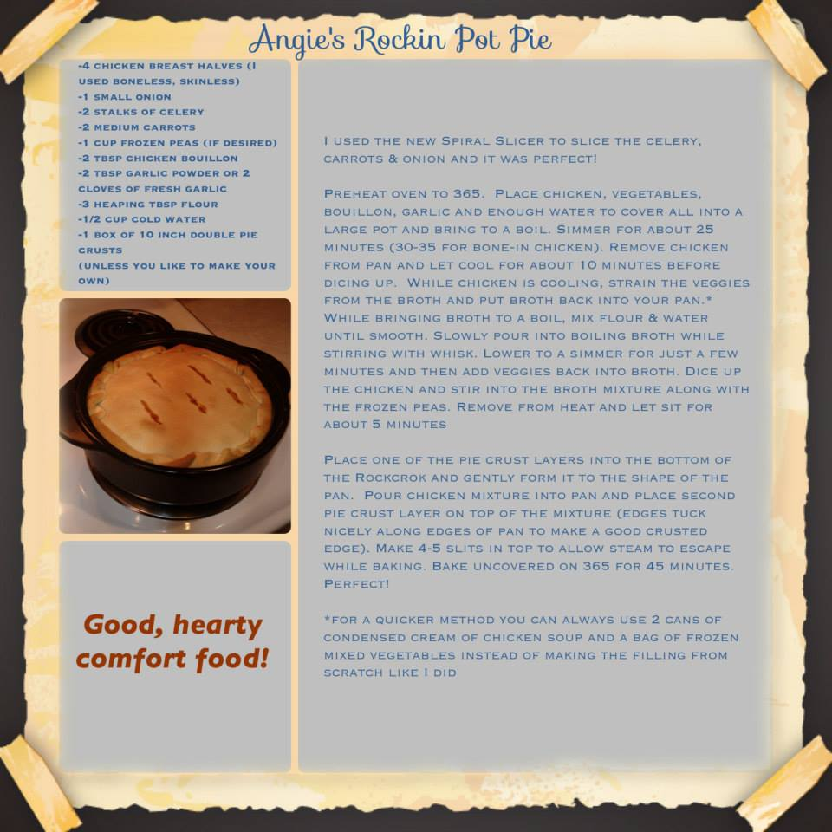
~ ~ ~ ~ ~ ~ ~ ~ ~ ~ ~ ~ ~ ~ ~ ~

Gluten & Dairy Free Chicken Pot Pie, Dumpling Style
Shared by Leslie Steinberg
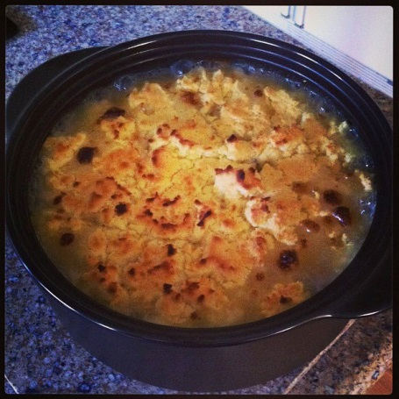

Ingredients
1 ½ pounds of boneless/skinless chicken breasts (or more)
3-4 carrots cut into bite sized pieces
2-3 celery stalks cut into bite sized pieces
1 medium onion cut up into bite sized pieces
2 Tbsp. bouillon (or use vegetable or chicken stock instead of water)
2 cloves of fresh garlic pressed
1-2 cups of quartered mushrooms
3 Tbsp. Tapioca Flour (or other gluten free flour) mixed in with ½ cup water.

Directions
- Put first 6 ingredients in RockCrok™ on stovetop on medium high heat with water (or broth) to just cover the vegetables and chicken. Bring to a boil and then simmer for about 20 minutes until chicken is cooked through.
- Remove chicken and when cooled enough to handle, use Salad Cchoppers to cut chicken into bite sized pieces.
- While vegetables and broth are continuing to simmer, pour the flour/water combo in to thicken stock. Add chicken back in and add in mushrooms at this time. Top with gluten free “biscuit” mixture (read below). Bake at 400 degrees for 16-20 minutes until biscuits are browned to your liking.

To make biscuits, I used Gluten Free Bisquick from the grocery store and followed directions on their box except where they added milk, I added plain water.
~ ~ ~ ~ ~ ~ ~ ~ ~ ~ ~ ~ ~ ~ ~ ~

Chicken & Gravy Recipe
Shared by Terry Colegrove
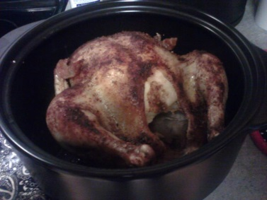

Ingredients
1 5lb Whole chicken
2 Tbsp. olive oil
Pampered Chef® Smoky Applewood rub (applied till chicken is covered)
1/3 cup water

Directions
- Place chicken in RockCrok™ Dutch Oven. Rub chicken with olive oil and Applewood Rub. Add water and cover. Place in microwave and cook for 30 minutes.
- Remove chicken from RockCrok™ to make gravy with the drippings on the stovetop. In Silicone Prep Bowl, mix together 3-4 tablespoons of flour with 1/4 cup of warm water using the Mini-Whipper. Add to the drippings and bring to a low boil. Stir until thickened.
~ ~ ~ ~ ~ ~ ~ ~ ~ ~ ~ ~ ~ ~ ~ ~

RockCrok™ Cashew Chicken
Presented by Stephanie Carey

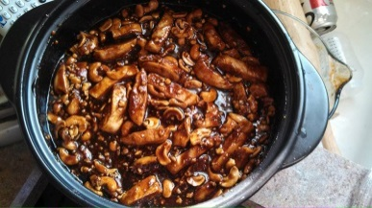
Ingredients
2 lbs (4 small) boneless & skinless chicken breast (thin cut)
1 cup cashews (divided)
1 garlic clove, minced
4 Tbsp. rice wine vinegar
¼ cup brown sugar
2 Tbsp. olive oil
1 tsp. grated fresh ginger root
1/4 cup all purpose flour
1/2 cup soy sauce
1 tsp. black pepper
1 tsp. Asian Seasoning (can substitute red pepper flakes)
2 Tbsp. ketchup
Directions
1. On your stovetop, heat oil in RockCrok™ Everyday Pan over medium heat. Meanwhile, mix flour & pepper in Coating Tray. Coat chicken with flour mixture, then add to pan to sear until juices of chicken run clear (about 10-15 minutes). Turn chicken every 5 minutes using Chef’s Tongs to ensure even cooking.
2. While chicken is cooking, grate the ginger root using the Microplane Adjustable Fine Grater, combine rice wine vinegar, brown sugar, ginger, soy sauce, ketchup, garlic, ginger and Asian seasoning in the Classic Batter Bowl. Whisk ingredients together using Stainless Whisk. Set aside.
3. Using the Manual Food Processor, crush ½ cup Cashews. Set aside.
4. Using Silicone Oven Mitts, remove RockCrok™ Everyday Pan from the stove on to the Stackable Cooling Rack. Take chicken out and place on Cutting Board to rest 5 minutes. Pour sauce from Classic Batter Bowl into the Rockcrock, using the Master Scraper to ensure all sauce gets out of the bowl and into the pan (it will bubble slightly). Place lid on Rockcrock and put in microwave to cook for 1-2 minutes (on high setting) for sauce to incorporate.
5. Slice chicken into ½” strips using 5” Utility Knife.
6. Remove RockCrok™ from the microwave using the Microwave Grips.
7. Add chicken to the RockCrok™. Sprinkle crushed cashews over the chicken and toss using Master Scraper. Add remaining cashews and toss into the sauce.
8. Optional: Serve over rice prepared in the Rice Cooker Plus and or with choice of vegetables prepared in the Micro-Cooker.
~ ~ ~ ~ ~ ~ ~ ~ ~ ~ ~ ~ ~ ~ ~ ~

Beef Mexican Casserole
By Rhoda Feuer

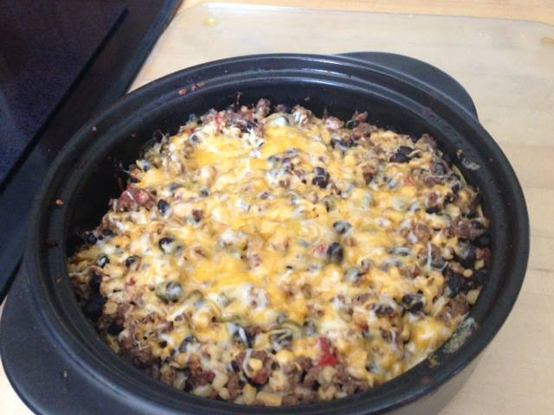
Ingredients
1 lb lean ground beef
1 Tbsp. Pampered Chef® Three Onion Rub
or
1/2 cup onions, chopped
1 can diced tomatoes with chilies, drained
1 can kernel corn, drained
1 can black beans, rinsed and drained
1-2 Tbsp. Pampered Chef® Southwest Seasoning
or
1 pkg. taco seasonings
8 corn tortillas
3/4 cup nonfat sour cream or nonfat Greek yogurt
1/3 cup reduced fat Colby/Jack cheese, shredded
1/3 bunch cilantro chopped to taste
Jalapenos (optional if you want it spicy)

Directions
- Brown ground beef and onions together in RockCrok™, drain if needed.
- Add corn, beans, canned tomatoes and seasoning, mix well and simmer until heated. Place mixture in a separate bowl so you can begin to layer the recipe.
- Place 4 tortillas on the bottom (use one more if you want the bottom covered)
- Spoon half of beef mixture on top, repeat layer.
- Preheat oven to 350 F and bake for 25 minutes.
- Remove from oven and sprinkle with cheese then broil briefly to brown cheese. Top with cilantro.

RockCrok™ Omelet
By Jessica Hartman Krawczak

Ingredients
2 small or medium potatoes, cut into ½” cubes
1 small onion, finely chopped
1 red Bell Pepper, coarsely chopped
2 Tbsp. COLD butter
8 oz Colby/Jack Cheese, grated, divided
8 Eggs
Salt/Pepper
1-2 Tbsp. Pampered Chef® Greek or Three Onion Seasoning
½ cup Heavy cream
2 Green onions tops and all, diced
6 Slices Bacon cooked crisp, chopped
Directions
- Place potato, onion and red pepper in Rockcrok™ and mix well to combine.
- Slice butter with Egg Slicer Plus and place on top of mixture.
- Cover, microwave on high for 6 minutes, stirring once (Or until potatoes are easily pierced with a fork)
- Top with half the grated cheese. In a separate bowl, beat eggs and add cream. Pour on top of cheese. Cover and microwave 14-16 minutes until set.
- Top with remaining cheese, bacon and green onions.
Season to taste.
~ ~ ~ ~ ~ ~ ~ ~ ~ ~ ~ ~ ~ ~ ~ ~

Homemade Hamburger Helper - Bernadette Story Howarth
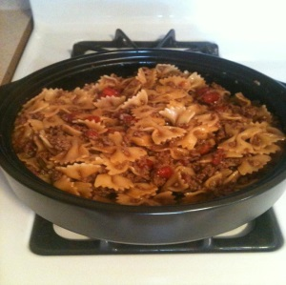
Ingredients
1-2 tbsp. olive oil
1 clove garlic
1 onion, chopped
1 lb. ground beef or turkey
1 (14oz.) can low sodium beef stock
1 (14 oz.) can Italian-style diced tomatoes
2 1/2 cups uncooked pasta, such as rotini, elbows, or bowtie
1 cup cheddar or mozzarella cheese, grated
Directions
- Heat olive oil in RockCrok™ Everyday Pan (RC) over medium heat until shimmering. Press garlic into pan and add onion, sauté briefly.
- Add ground meat and brown, breaking into crumbles with Mix 'N Chop. Drain fat if necessary.
- Add stock, tomatoes with juice and pasta. Add a little water, if needed, to just cover the pasta. Bring to a boil, then reduce heat and simmer until pasta is done and most of the liquid is absorbed (about 15 min.)
- Remove from heat, sprinkle cheese on top and cover with lid for 2 minutes or until cheese melts.
~ ~ ~ ~ ~ ~ ~ ~ ~ ~ ~ ~ ~ ~ ~ ~

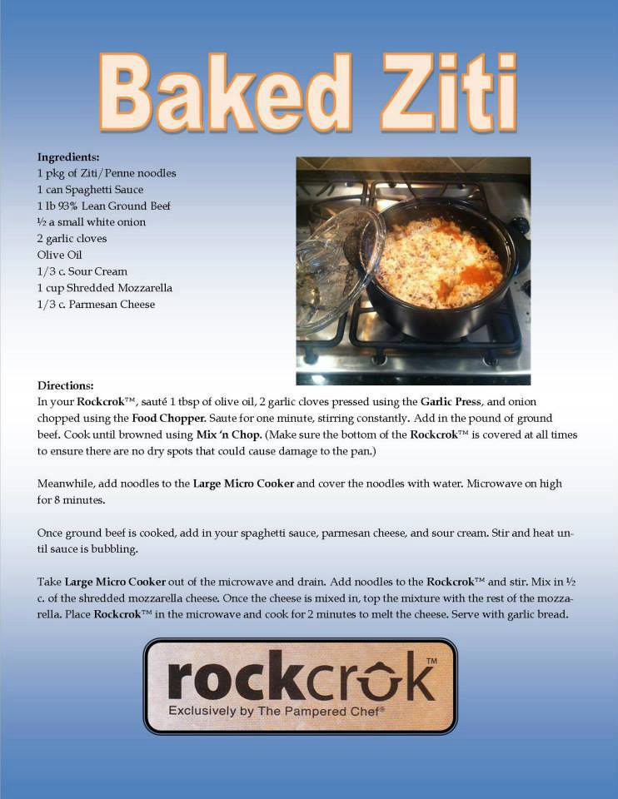

~ ~ ~ ~ ~ ~ ~ ~ ~ ~ ~ ~ ~ ~ ~ ~

RockCrok™ Chicken Pasta!
Desiree Griffith Rose
Love simple meals! This is done in 15 minutes! So easy and soooo good!

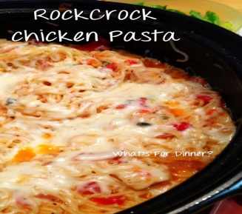
Ingredients
2 lbs chicken breasts, boneless & skinless (I used one package of breasts)
12 oz whole wheat pasta (we used angel hair)
1-14.5 oz can diced tomatoes with juice (can use plain, roasted, zesty red pepper, or whatever’s in your pantry: we had diced with garlic)
1 large sweet red onion, cut in strips
2-5 pressed cloves of garlic
1 Tbsp. of Pampered Chef Italian seasoning
1 package of fresh basil chopped
4 C chicken broth (one carton low sodium)
2 Tbsp. olive oil, divided (I used the Pampered Chef garlic infused oil)
Parmesan cheese for garnish (I used mixed Italian blend)
Salt & pepper to taste
Directions
- On stovetop over medium-high, heat 2 Tbsp olive oil in RockCrok™ Dutch Oven.
- While pan is heating, cut chicken breasts into bite sized pieces. Add chicken to pot and season with salt and pepper, turning to cook thoroughly.
- Once chicken has browned, add remaining ingredients, excluding the parmesan cheese. Cover and bring to a boil.
- Once boiling, reduce heat to a simmer, keep covered and cook for 10 minutes, stirring every 2 minutes to avoid pasta from sticking. Very Important to STIR!!
- After cooking for 10 minutes, remove from heat, remove lid and let set 5 minutes to cool and thicken.
- Sprinkle parmesan cheese as garnish and place lid on pot to melt.

~ ~ ~ ~ ~ ~ ~ ~ ~ ~ ~ ~ ~ ~ ~ ~

CHERRY VANILLA CAKE
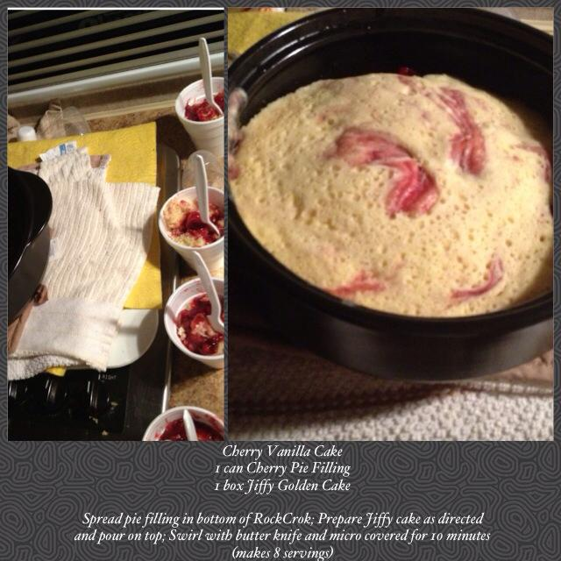

~ ~ ~ ~ ~ ~ ~ ~ ~ ~ ~ ~ ~ ~ ~ ~
Cheeseburger Meatballs & Pasta
Recipe by The Pampered Chef®
Presented by Dawn Nabours



Ingredients
2 slices white sandwich bread, torn into pieces
1 small onion, finely chopped
1 egg
¾ tsp. (4 mL) each salt and ground black pepper
12 oz (350 g) 90% lean ground beef
1 Tbsp. (15 mL) canola oil, divided
3 cups (750 mL) chicken stock
2 Tbsp. (30 mL) flour
6 oz (175 g) uncooked campanelle pasta (11/2 cups/375 mL)
4 oz (125 g) chive & onion 1/3 less fat cream cheese spread
6 oz (175 g) sharp cheddar cheese, shredded (1 1/2 cups/375 mL), divided
2 cups (500 mL) broccoli florets
Directions
- Combine bread, onion, egg, salt and pepper in a large bowl; mix until a smooth paste forms. Add beef; mix gently but thoroughly. Using a level Small Scoop, scoop beef mixture, forming about 36 meatballs.
- Heat 1/2 Tbsp. (2 mL) of the oil in (2.5-qt./2.35-L) Everyday Pan over medium heat 2-4
minutes or until shimmering. Cook half of the meatballs 3-4 minutes or until browned, turning
occasionally. Remove from Pan. Repeat with remaining oil and meatballs; remove from Pan.
- Whisk stock and flour until smooth; add to Pan. Stir in pasta; cook, covered, 9-11 minutes or until pasta is almost tender, stirring occasionally. Stir in cream cheese spread and half of the cheddar until sauce is smooth. Stir in broccoli and meatballs. Cook, covered, 2-3 minutes or until broccoli is tender; remove from heat.
- Top with remaining cheddar; cover and let stand 1-2 minutes or until cheese is melted.
Yield: 6 servings
U.S. Nutrients per serving: Calories 450, Total Fat 23 g, Saturated Fat 11 g, Cholesterol 110 mg,
Sodium 890 mg, Carbohydrate 30 g, Fiber 2 g, Protein 28 g
~ ~ ~ ~ ~ ~ ~ ~ ~ ~ ~ ~ ~ ~ ~ ~

Veggie Taco Base
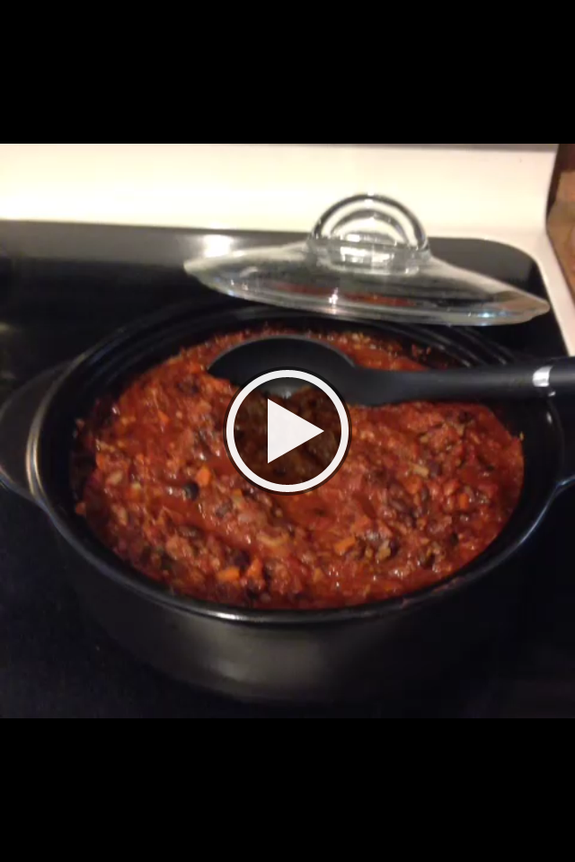
Presented by Lisa Adkins

Ingredients
1 onion
2-3 carrots
1 small squash
1 small container sliced portabella mushrooms
1 can black beans, drained & rinsed
1 can of diced/crushed tomatoes
1-2 TB homemade taco seasoning (http://www.familyfreshmeals.com/2013/05/diy-homemade-taco-seasoning.html) OR Tex Mex Rub, Chipotle Rub, etc.

- Process onion in Manual Food Processor, and dice carrots – add to preheated RockCrok™ (on stove) – with a LITTLE water to soften. Meanwhile, process squash and mushrooms, doing one at a time (it won’t all fit otherwise). Add to RockCrok™, along with taco seasoning, and let moisture release and reduce from mushrooms and squash.
Add all to RockCrok™ with taco seasoning, cover, and microwave until softened).
- Add tomatoes, and black beans to RockCrok™ and stir. Cook on stovetop on medium until liquid is reduced to taco filling consistency.
- Add to taco shells with vegan sour cream.

Taco Salad:
Cut romaine lettuce and add to Salad & Berry Spinner. Rinse in colander, spin to dry. Transfer to serving platter. Add can of drained corn, sliced avocado, and taco mixture. Combine vegan sour cream with juice of lime, and 1 TB of Chili Lime Rub – put in Ziploc and squirt over salad (if thick enough). Put tortilla chips in the bottom of each serving bowl before serving the salad for the crunch.

Easy Chicken Pot Pie
Recipe from The Pampered Chef® Deep Covered Baker Cookbook
Presented by Kathy Piemonte

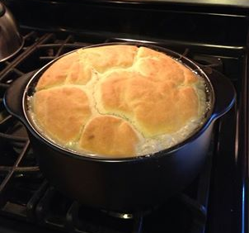
Ingredients
½ cup butter (1 stick) melted
½ cup all-purpose flour
3 cups chicken stock
1 tsp. salt
½ tsp. black pepper
1 medium onion *
2 tsp. finely chopped fresh thyme leaves*
2 garlic cloves*
3 cups diced cooked chicken breasts**
1 cup 2% milk*
2 cups frozen mixed peas and carrots***
½ package frozen puff pastry sheets (1 sheet) thawed*
1 egg*
1 Tbsp. water*
* I omitted these ingredients. When I added the milk before, it tended to be too watery. We did not like the Thyme either.
** I used a roasted chicken already cooked from the grocery store. 2 if doubling.
*** I used mixed vegetables with corn, etc. Also used a bag of broccoli florets. I cooked the 2-3 minutes in the microwave first.
Directions
- Preheat oven to 375 F. Combine butter and flour and whisk until smooth. Add to RockCrok™ and cook over medium-high heat until mixture is light brown, whisking occasionally.
- Add stock, whisking constantly until smooth. Add thyme, pressed garlic, salt and black pepper (and onion if desired.) Simmer and cook uncovered 6-8 minutes or until sauce is thickened. Remove from heat. Stir in chicken and (milk – I omitted).
Add vegetables and chicken. Stir.

Topping is from the Pampered Chef Cookbook, It is Good for You (discontinued)
Turkey Vegetable Cobbler:

Biscuit Topping:
1 ¼ cups all-purpose baking mix (calls for reduced-fat)
½ cup 2% milk
1 egg white

Combine and stir until dry ingredients are moistened and mixture forms soft dough. Drop scoops of dough over top.
Bake for 30-35 minutes, uncovered.

Chicken Tortilla Casserole
Laurie Garza-Carl

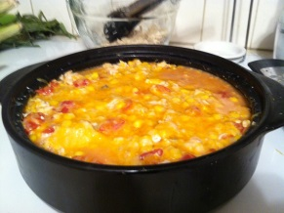

I was too lazy to run to store for missing ingredients for intended recipe. Played with what I had on hand and came up with this super yummy new recipe. I used the RockCrok™, but our much loved Deep Covered Baker would work as well. Enjoy!
Ingredients:
- 1 can of diced tomatoes (use rotel for some heat)
- 1 cup of corn (can, frozen or fresh)
- 1 can (10 3/4 oz) cream of chicken soup
- 1 can cream of mushroom soup
- 2 TBSP. of The Pampered Chef Chipotle Rub
- 2 garlic cloves, pressed with garlic press
- 2 cups diced chicken
-12 corn tortillas
-2 cups shredded cheese
Optional: Cilantro
Directions:
1. In Batterbowl, mix tomatoes, corn, cream of mushroom and chicken soups, Chipotle Rub, garlic and chicken. Mix well.
2. In Deep Covered Baker or RockCrok™, cover bottom with a layer of corn tortillas. Note: I "dipped" the bottom of the tortillas in chicken mixture before placing into my RockCrok™. Top tortillas with chicken mixture, then grate cheese over chicken. Repeat layers.
3. If your chicken is cooked, microwave for 8 minutes, covered. If you use diced raw chicken, then microwave for 15 minutes.
Dinner is done!

Cheesy Shells & Italian Sausage
Pampered Chef Recipe, Picture by Gwendolyn Theresa Longino

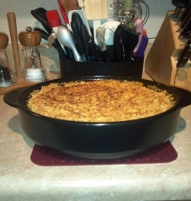
8 oz (250 g) bulk hot Italian pork sausage (see Cook’s Tip)
3 garlic cloves
3 cups (750 mL) unsalted chicken stock
1 jar (24 oz/680 mL) marinara sauce (2½ cups/625 mL)
12 oz (350 g) medium shell pasta
4 oz (125 g) reduced-fat cream cheese (Neufchâtel)
¼ cup (50 mL) fresh basil leaves
1 cup (250 mL) seasoned croutons
2 oz (60 g) fresh Parmesan cheese (½ cup/125 mL grated)
1. Preheat broiler. Cook sausage in RockCrok™™ (2.5-qt/2.35-L) Everyday Pan or RockCrok™™ (4-qt/3.8-L) Dutch Oven over medium heat 4-6 minutes, breaking into crumbles with Mix ‘N Chop.
2. Remove RockCrok™™ from oven and place on stove. Turning on to medium heat. Press garlic with Garlic Press into Pan. Cook 30-60 seconds or just until fragrant.
3. Stir in stock, marinara and pasta to Pan. Increase heat to high; cover and bring to a boil. Reduce heat to medium and cook, stirring occasionally, 7-9 minutes or until pasta is cooked but firm.
4. Meanwhile, chop basil with Chef’s Knife. Process croutons in Manual Food Processor until finely chopped; place in Classic Batter Bowl. Grate Parmesan with Microplane® Adjustable Fine Grater over batter bowl. Mix crouton/Parmesan mixture well.
5. Remove Pan from heat. Stir in cream cheese and basil until blended. Sprinkle cheese mixture evenly over pasta. Place Pan 2-4 in. (5-10 cm) from heating element. Broil 1-2 minutes or until top is golden brown.
Serves 8
U.S. Nutrients per serving: Calories 370, Total Fat 15 g, Saturated Fat 4.5 g, Cholesterol 30 mg, Sodium 830 mg, Carbohydrate 43 g, Fiber 3 g, Protein 18 g
Cook’s Tip: 8 oz (250 g) Italian turkey sausage (2 links, casings removed) or 8 oz (250 g) 90% lean ground beef can be substituted for the bulk Italian pork sausage, if you’d like.

S’more Cake
Recipe
3 milk chocolate candy bars (1.55 oz or 43 g each), broken into squares
1 small pkg (9 oz) devil’s food cake or 1 2/3 cups (400 mL) from a regular-size package
1 egg
1 container (8 oz or 250 mL) sour cream
1 bag (10 oz or 300 g) regular-size marshmallows or 4 cups (1 L) mini marshmallows
3 whole graham crackers, coarsely crushed

Place oven rack in middle of oven; preheat broiler.
Microwave chocolate in (2-cup/500-mL) Prep Bowl on HIGH 30-60 seconds or until mostly melted. Stir until smooth; set aside.
Combine cake mix, egg and sour cream in Classic Batter Bowl; mix using Small Mix ‘N Scraper® until blended. Pour batter into RockCrok™™ (2.5-qt./2.35-L) Everyday Pan or RockCrok™™ (4-qt./3.8-L) Dutch Oven.
Microwave, covered, on HIGH 4-5 minutes or until center of cake is firm and springs back when pressed.
Remove pan from microwave; arrange marshmallows in an even layer over cake. Broil 30-60 seconds or until marshmallows are golden brown. Remove from broiler; sprinkle with crackers and drizzle with chocolate.
Quick Pineapple

Upside-Down Cake

Family-Size Cheeseburger & Fries
Recipe by The Pampered Chef ®
4 oz (125 g) cheddar cheese
1 piece white sandwich bread, torn into pieces
1 egg
3 Tbsp. (45 mL) Three Onion Rub
1 lb (450 g) 90% lean ground beef
1/4 tsp. (1 mL) black pepper
3 garlic cloves, pressed
1/2 cup (125 mL) ketchup, divided
1 1/2 Tbsp. (22 mL) yellow mustard
2 small dill pickles
1 1/4 cups (300 mL) canned shoestring potatoes or coarsely crushed potato chips
chopped fresh parsley (optional)

- Grate cheese using Microplane® Adjustable Coarse Grater. Process bread in Manual Food Processor until finely chopped. Add egg and 2 Tbsp. (30 mL) of the rub; process until well combined. Remove to large Bamboo Fiber Bowl.
- Add beef, pepper, garlic pressed with Garlic Press, 1/4 cup (50 mL) of the ketchup, half of the cheese, and mustard to bread mixture in bamboo bowl. Mix well using gloved hands.
- Form beef mixture into a ball, packing firmly; transfer to RockCrok™™ (2.5-qt./2.35-L) Everyday Pan. Press into a patty to within ½-in. (1-cm) from edges of Pan to an even thickness. Cook, covered, over medium heat 3-6 minutes or until meat begins to sizzle on the sides.
- Remove Pan from heat; transfer to microwave. Microwave, covered, on HIGH 3-4 minutes or until internal temperature reaches 160°F (71°C) in center of patty.
- Meanwhile, combine remaining 1 Tbsp. (15 mL) rub and remaining ¼ cup (50 mL) ketchup in (1-cup/250-mL) Prep Bowl; mix well. Thinly slice pickles using Utility Knife.
- Mix together remaining cheese and potatoes in Classic Batter Bowl.
- Carefully remove Pan from microwave. Blot excess moisture from top of patty with paper towel and drain, if necessary. Spread ketchup mixture evenly over patty and top with pickles. Top with cheese and potato mixture.
- Microwave, uncovered, an additional 2-3 minutes or until cheese is melted. Sprinkle with parsley, if desired.
Yield: 8
Nutrients per serving: Calories 330, Total Fat 19 g, Saturated Fat 8 g, Cholesterol 95 mg, Sodium 860 mg, Carbohydrate 15 g, Fiber 1 g, Protein 21 g

Cook's Tip: You may use ¼ cup (50 mL) finely chopped onion in the meat mixture and 1 Tbsp. (15 mL) finely chopped onion in the ketchup mixture in place of the Three Onion Rub.

Cheesy Bruschetta Recipe
Recipe by The Pampered Chef ®
2 oz (60 g) mozzarella cheese
1 oz (30 g) fresh Parmesan cheese
3 Tbsp. (45 mL) butter, cut into pieces
1 garlic clove, pressed
10-12 slices (1/4-in./6-mm thick) French baguette
Toppers: prepared pesto, marinara sauce or tapenade (optional)

1. Preheat broiler. Grate mozzarella with Microplane® Adjustable Coarse Grater. Grate Parmesan with Microplane® Adjustable Fine Grater. Combine cheeses in (2-cup/500mL) Prep Bowl; set aside.
2. Melt butter in RockCrok™™ (2.5-qt./2.35-L) Everyday Pan or RockCrok™™ (4-qt./3.8-L) Dutch Oven over medium-low heat. Press in garlic with Garlic Press; stir. Arrange bread slices over butter mixture.
3. Toast bread 1-3 minutes or until bottoms begin to brown; rotating pieces as necessary to brown evenly. Remove pan from heat.
4. Sprinkle cheeses over bread. Place pan 2-4 in. (5-10 cm) from heating element. Broil 2-4 minutes or until cheese is light golden brown; remove from oven. Serve with desired Toppers.
Yield: Serves 6
Nutrients per serving: Calories 130, Total Fat 9 g, Saturated Fat 5 g, Cholesterol 25 mg, Sodium 240 mg, Carbohydrate 6 g, Fiber 0 g, Protein 5 g

Zesty Ravioli - RockCrok™
Yield: 8 servings
1/3 cup heavy whipping cream or 4 ounce of softened cream cheese
4 cups loosely packed fresh baby spinach leaves
6 oz provolone or parmesan cheese, grated
8-12 oz shredded mozzarella cheese
1 Tbsp. olive oil
1 small jalapeño pepper, seeded
½ medium onion
3 garlic cloves, pressed
2 cans (14.5 oz each) diced tomatoes, undrained
1/2 tsp. salt
1/2 tsp. coarsely ground black pepper
1 pkg (24 oz) small frozen cheese ravioli (about 65)
Measure cream using Easy Read Measuring Cup. Wash spinach in large Stainless Mesh Colander; drain. Grate cheese using Coarse Cheese Grater. Set aside cream, spinach and cheese.
Add oil to Dutch Oven RockCrok™. Finely chop jalapeño and onion with Manual Food Processor. Add jalapeño, onion and garlic pressed with Garlic Press into RockCrok™; microwave on HIGH 1 minute.
Add tomatoes, salt, black pepper; and ravioli to the RockCrok™; cover and microwave on HIGH 10 minutes, stir and microwave another 10 minutes. Stir in cream and shredded cheese; cover and let stand 1-2 minutes or until cheese is melted.
Nutrients per serving: Calories 400, Total Fat 20 g, Saturated Fat 11 g, Cholesterol 65 mg, Carbohydrate 37 g, Protein 19 g, Sodium 870 mg, Fiber 3 g
Cook's Tip: Wear plastic gloves when working with jalapeño peppers. The juice from the peppers can create a burning sensation on the skin.
For a dish with more heat, do not seed the jalapeño pepper.
© 2009 The Pampered Chef used under license.

Italian Pot Pie
Recipe by The Pampered Chef ®
Adapted for the RockCrok™ by Linda Haworth Child
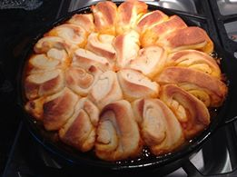
Ingredients:
1 - 1 1/2 lbs bulk hot Italian sausage
1 medium red onion
1 medium green bell pepper
8 oz mushrooms
3 garlic cloves, pressed
1 can (15 oz) pizza sauce (1 3/4 cups)
1 can (14.5 oz) diced fire-roasted tomatoes , undrained
1 pkg (13.8 oz) refrigerated Pillsbury pizza crust
1 1/2 cups shredded mozzarella cheese
1 tsp. olive oil
Grated fresh Parmesan cheese (optional)
Italian Seasoning Mix (optional)
Directions:
• Preheat oven to 400°F. Cook sausage in Rockcrok over medium-high heat 4–5 minutes or until browned, breaking into crumbles using Mix ‘N Chop.
• Slice onion with Spiral and Slice.
• Wedge bell pepper with Chef's Knife and chop in the Manual Food Processor.
• Slice mushrooms using Egg Slicer Plus.
• Add onion, bell pepper, mushrooms and garlic pressed with Garlic Press to Rockcrok; cook 1–2 minutes or until bell pepper is crisp-tender, stirring occasionally with Small Mix ‘N Scraper.
• Open Pizza Sauce with Jar Opener and Tomatoes with Smooth Edge Can Opener, stir both into sausage mixture; cook 1–2 minutes or until simmering. Cover; remove from heat.
• Place pizza dough onto Large Flexible Cutting Mat (do not unroll). Using a sawing motion, slice dough in half lengthwise with Color Coated Bread Knife; slice dough halves crosswise into 12 half moons for a total of 24 half moons.
• Grate Mozzarella Cheese with Microplane Coarse Grater and sprinkle over sausage mixture. Arrange dough slices over cheese in a circular pattern, spacing about 3/4 inch apart (you will probably have a few left over, do not crowd these as they will not get done all the way and be ‘doughy’). Spritz dough with oil using Kitchen Spritzer.
• Bake, uncovered, 12–15 minutes or until crust is golden brown. Carefully remove Rockcrok from oven with Silicone Oven Mitts.
• Grate Parmesan cheese using the Deluxe Cheese Grater over the baked crust and sprinkle with Italian Seasoning Mix, if desired. Let stand 5 minutes.
Yield: 8 servings Cook's Tip: If desired, 1 (14.5-oz) can Italian-seasoned diced tomatoes can be substituted for the fire-roasted tomatoes.

